

**INSTRUCTOR INFORMATION**

Loy Vanich

084 007 5544

Line ID: laployv

laploy@gmaill.com

www.laploy.com

**TIME FRAME**

* Course duration
* Start time
* Coffee break
* Lunch break
* Course end

**REPOSITORY**

https://github.com/laploy/BI2018

**SOFTWARE REQUIREMENT**

* Windows 10
* Microsoft Office latest version

**Introducing**

**Power BI**

### What is Power BI?

* A business analytics service provided by Microsoft.
* It provides interactive visualizations with self-service business intelligence capabilities
* End users can create reports and dashboards by themselves
* Without having to depend on information technology staff or database administrators.

### Power BI VS SSRS

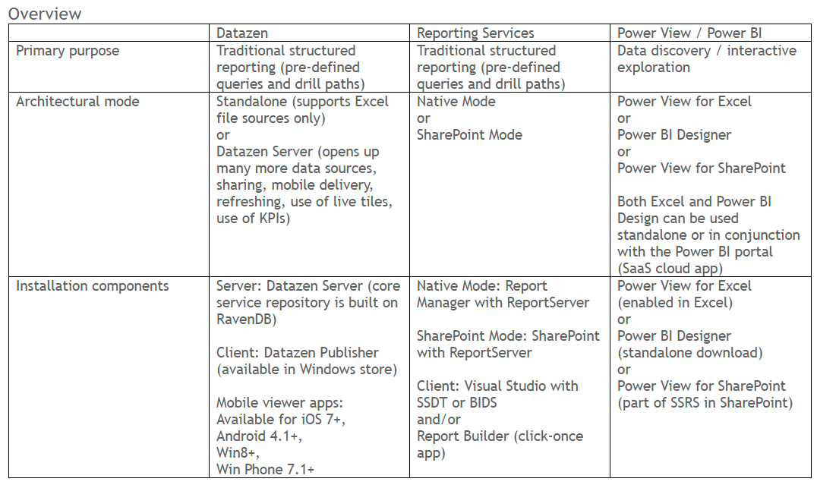

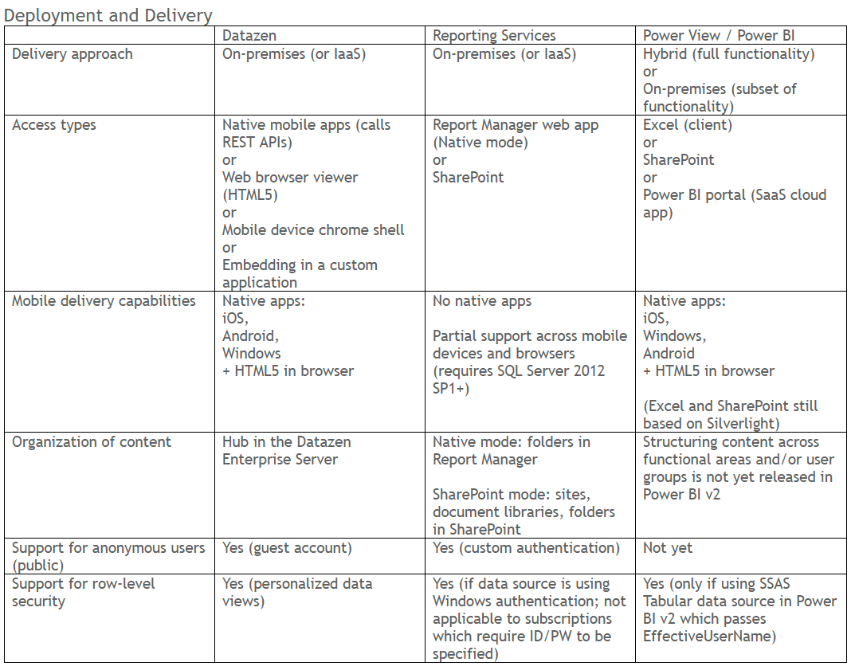

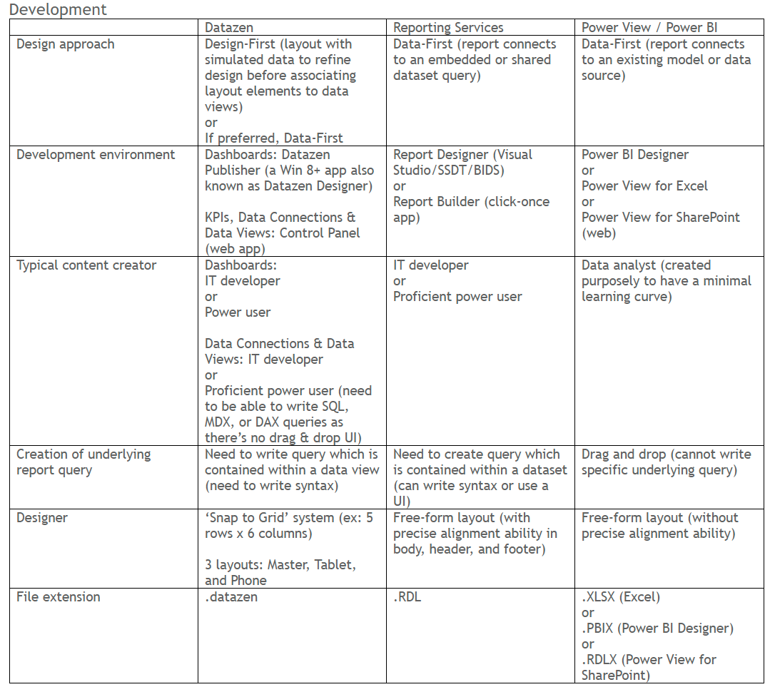

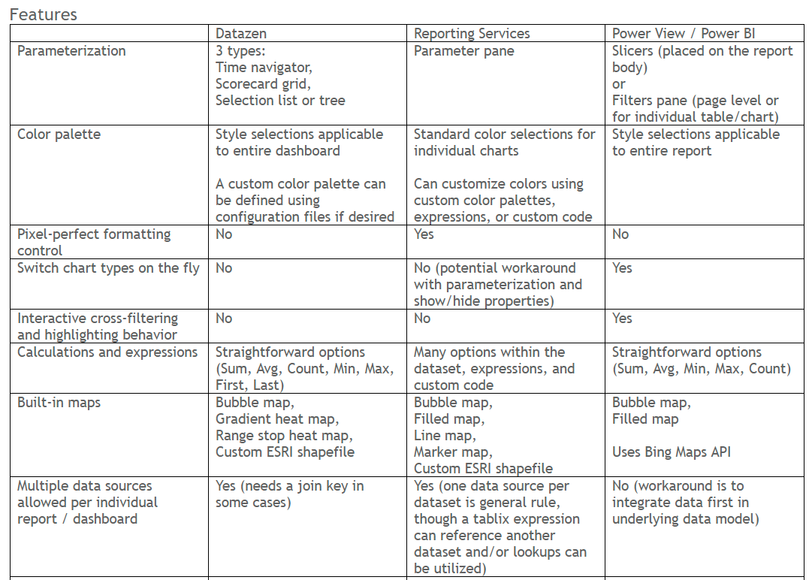

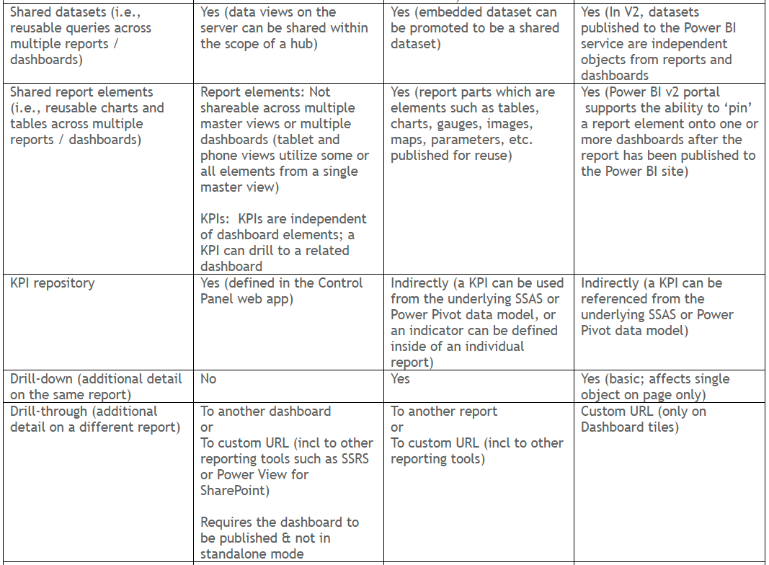

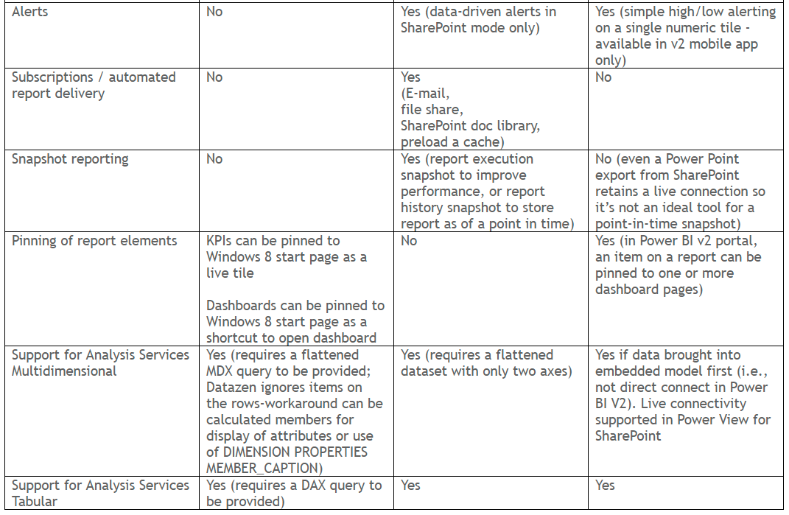

### Power BI editions

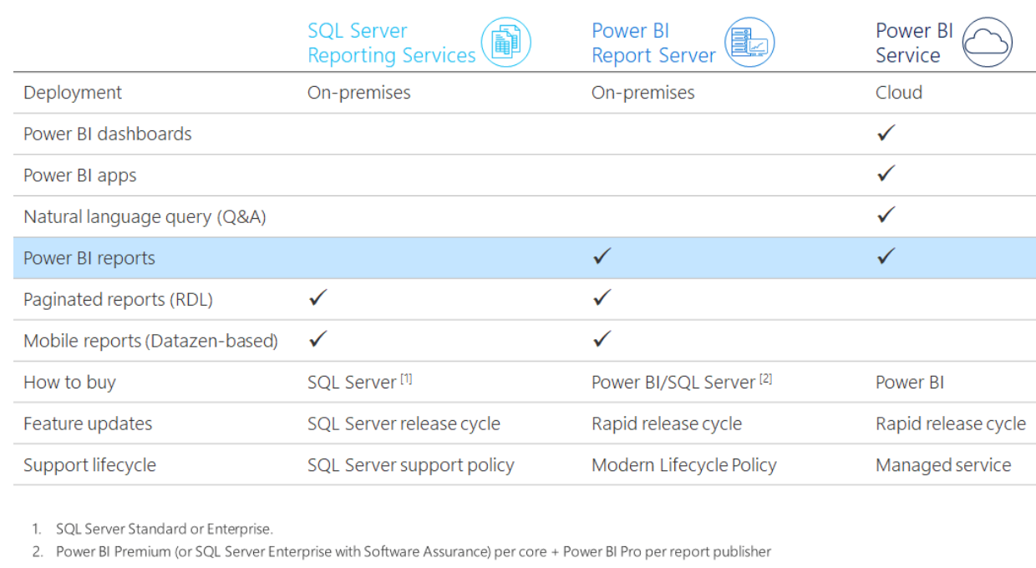

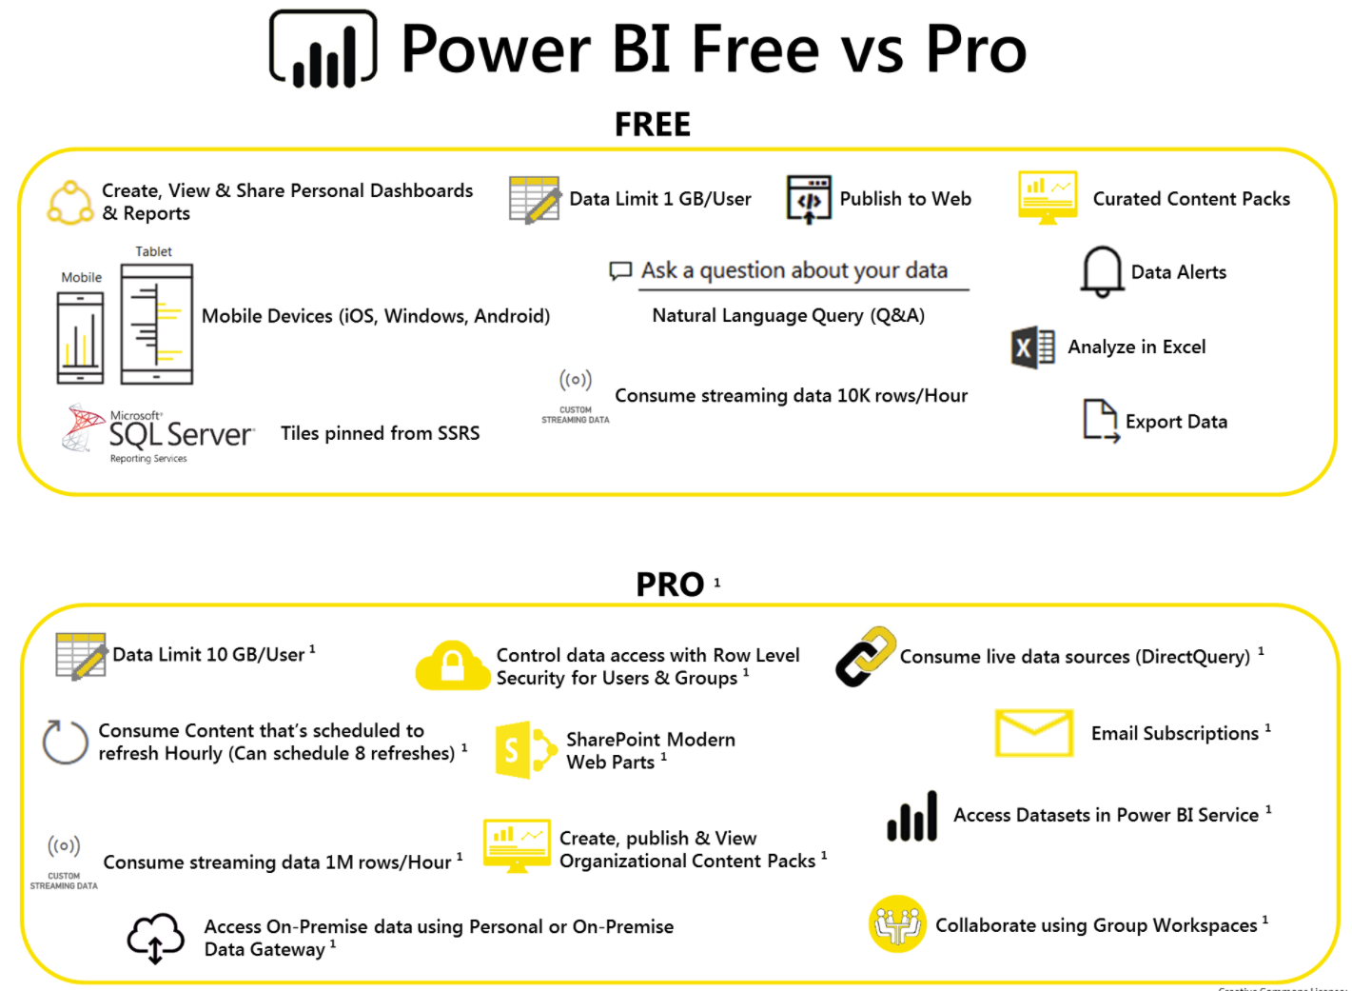

**Example Scenario**

### Example scenario

* manager of budgeting
* Company = Contoso
* Sells = electronic products
* Where = worldwide
* Channel = retail shops and a website
* Scenario = David aggregates budget data from country/region managers around the globe
* Target = produce the big picture to show to his boss.

### Report scenario

* Work start = October 2015
* Job = 2016 budget
* Data Tool = Microsoft Excel workbook
* Presentation tool = Microsoft PowerPoint
* Where = internal meetings
* New approach = This year, however, David wants to take advantage of the new Power BI service provided by Microsoft

### Topic Scope

* This course = walkthrough with Power BI can help to build a rather sophisticated reporting solution
* Out of scope = budget building technique
* In scope = teamwork, data modeling, and reporting
* To do = replicate activities

### Data file

* Data file = 2015 Sales.xlsx
* Data = sales for the past three years
* Divided = country/region, brand, and month

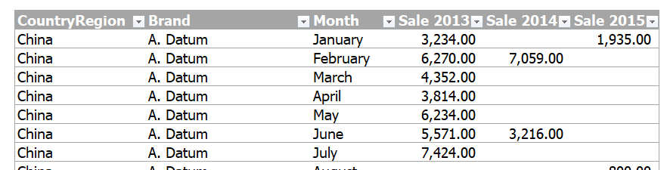

### Some brands are prone to seasonal effects



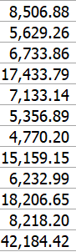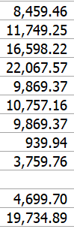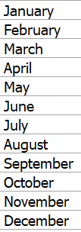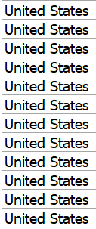

### Budget plan’s Workflow

David consider numbers

David share with managers

2013-2015

Workbook

From IT

Managers send back 2016 workbooks

2016 workbook

Meetings with experience, knowledge, charts, calculations, and presentation

Must be streamline!

**Setting up**

**Power BI**

Go to Microsoft Power BI home page

https://powerbi.microsoft.com/en-us/

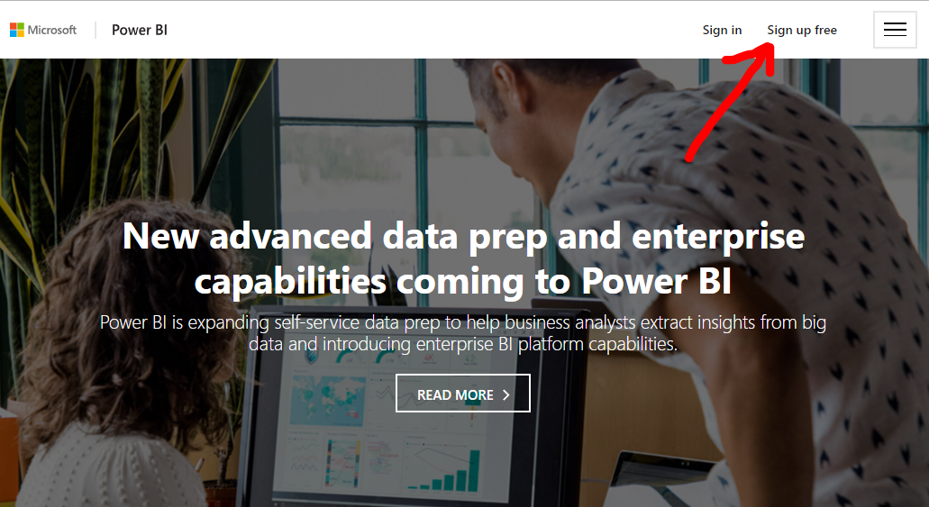

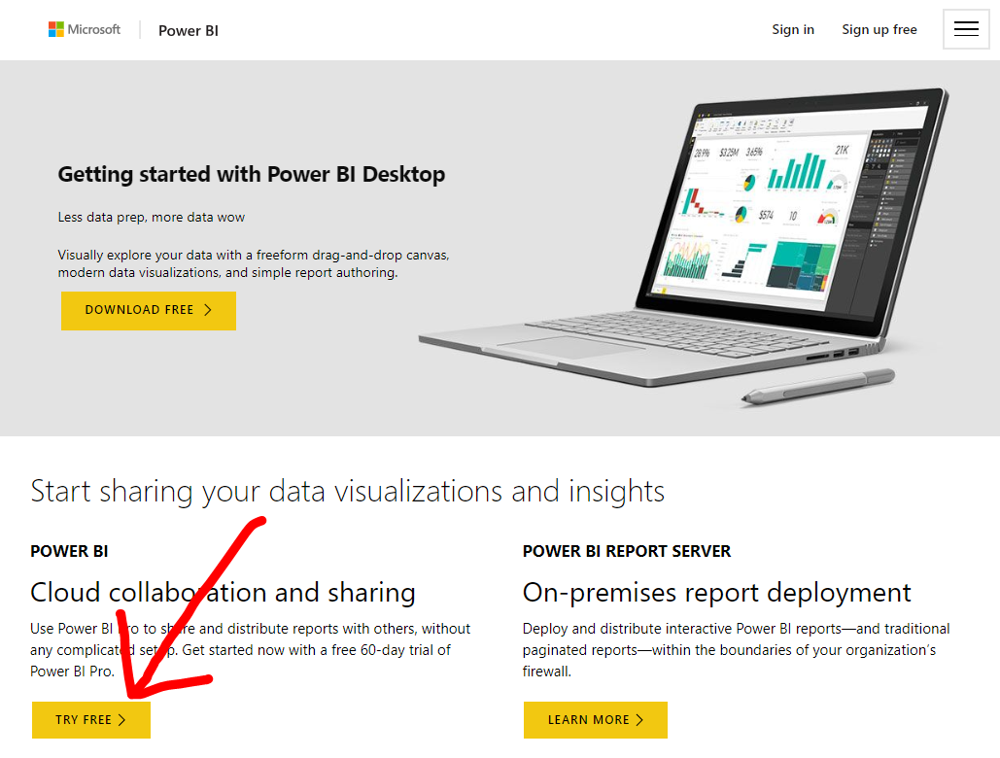

Sign up using Cooperate or Academic email

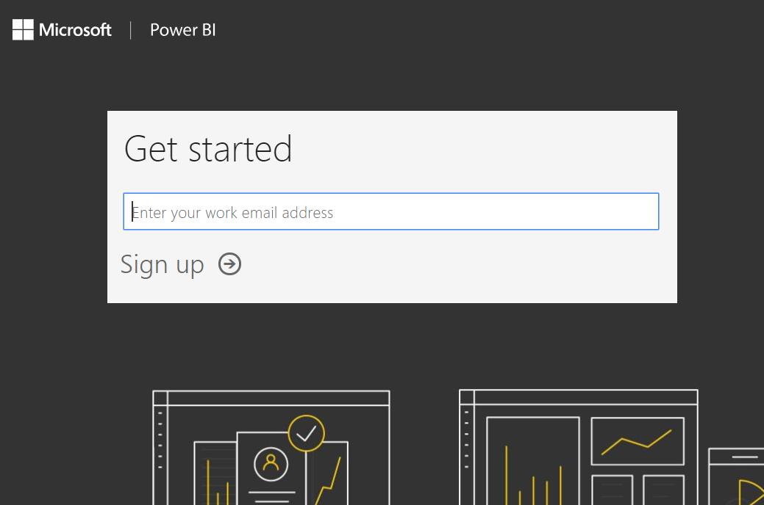

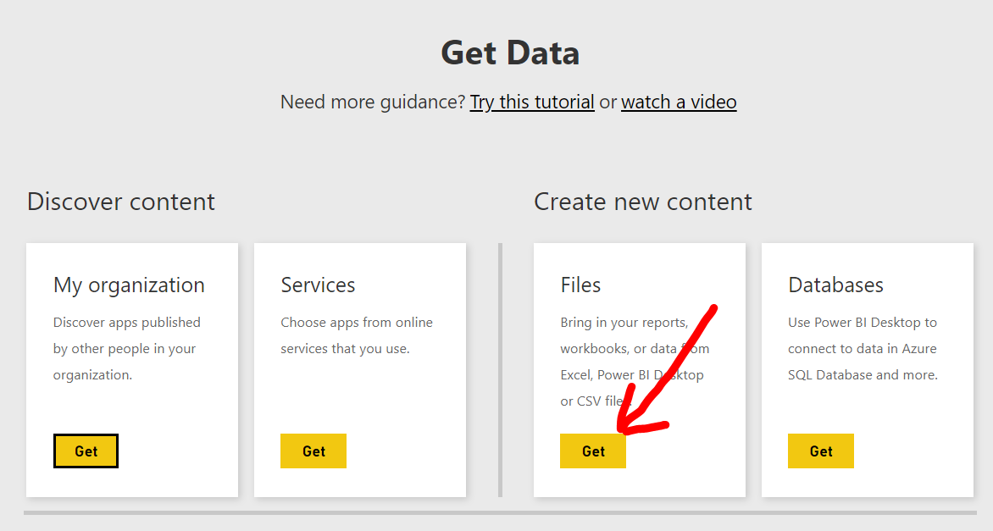

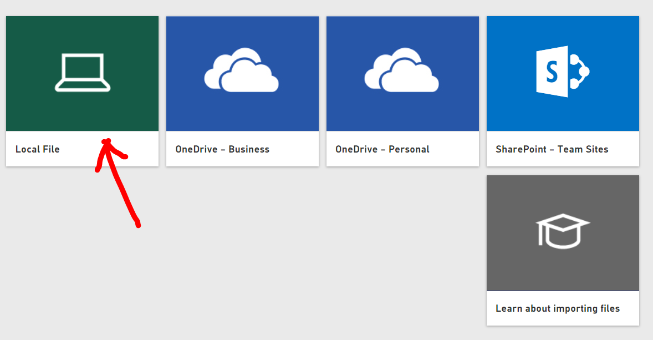

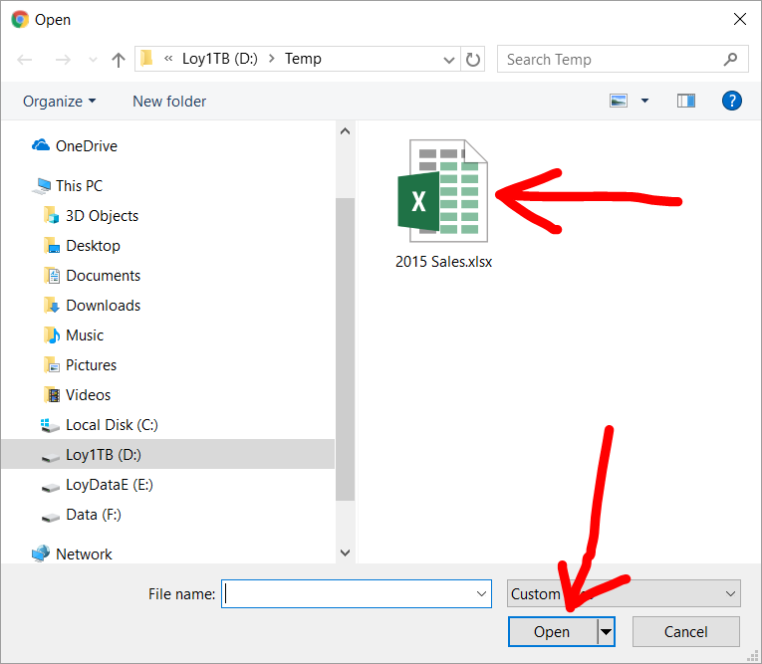

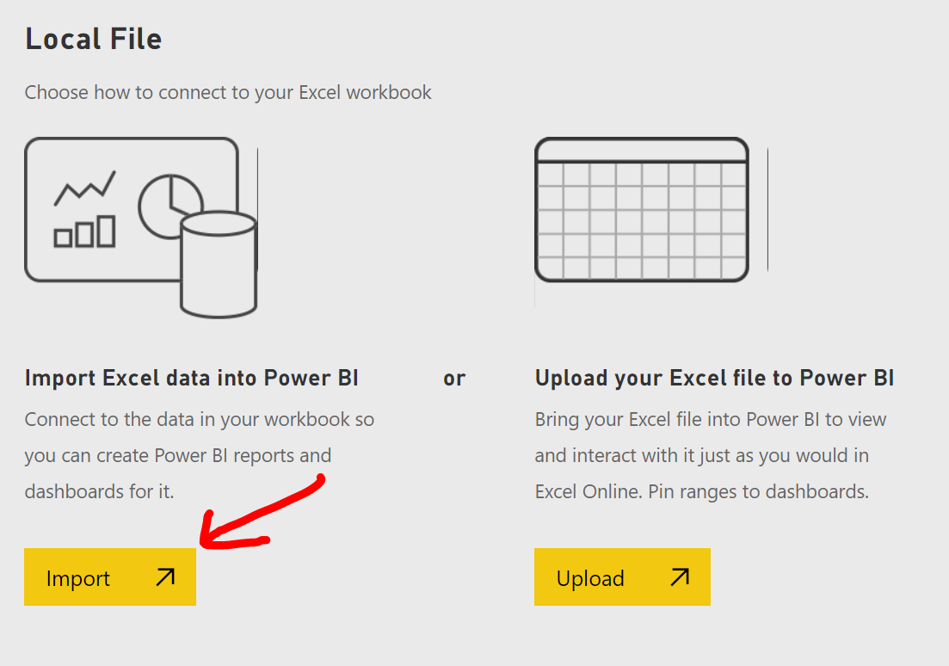

**Supplier Quality Analysis sample**

Supplier Quality Analysis

* Understand who the best and worst suppliers are, with respect to quality
* Identify which plants do a better job finding and rejecting defects, to minimize downtime

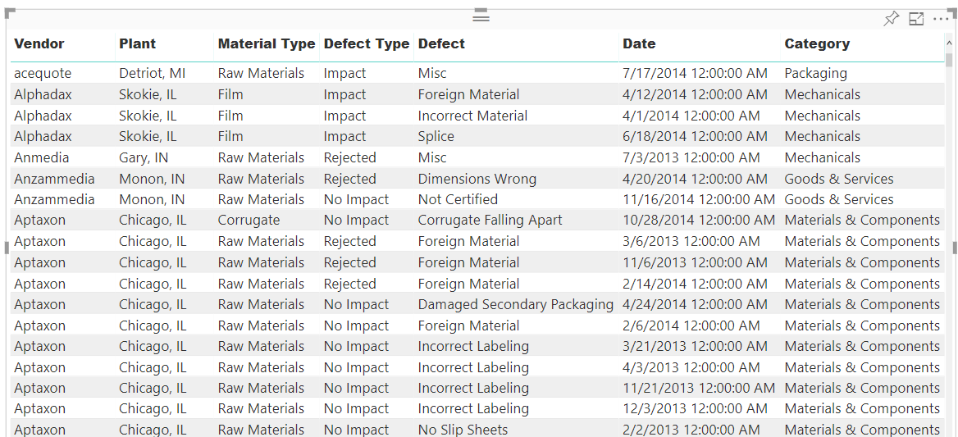

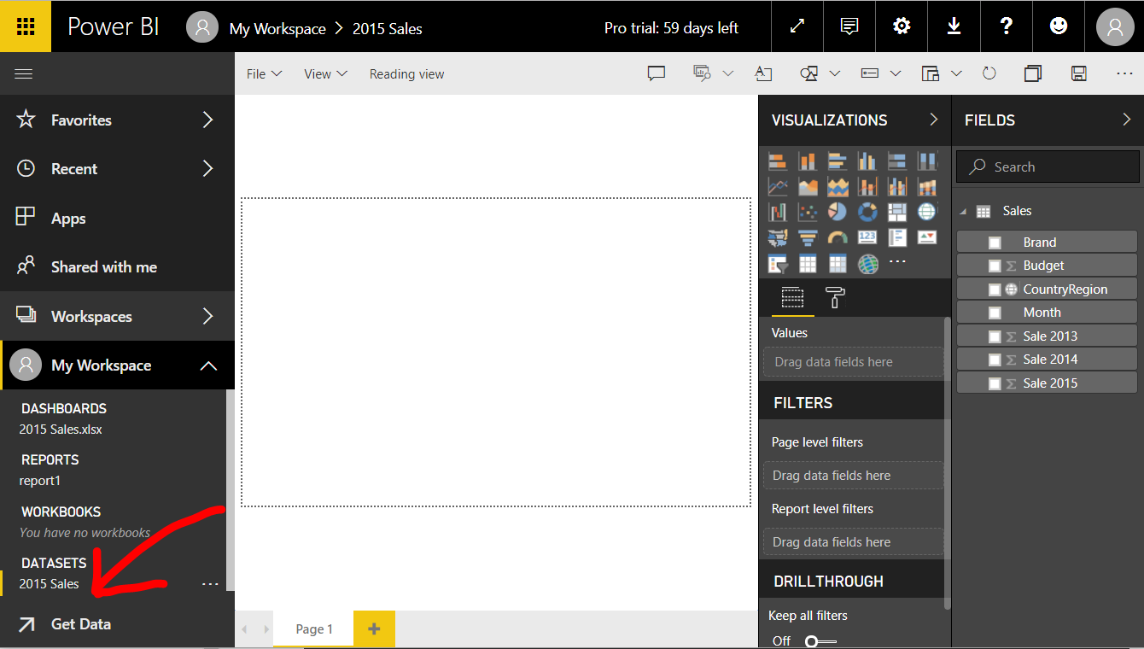Get Data

Sample

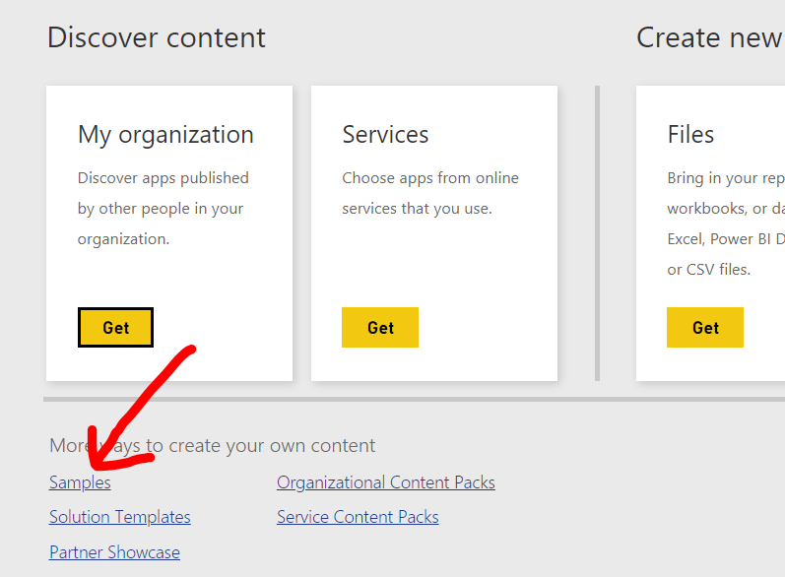

Supplier Quality Analysis Sample

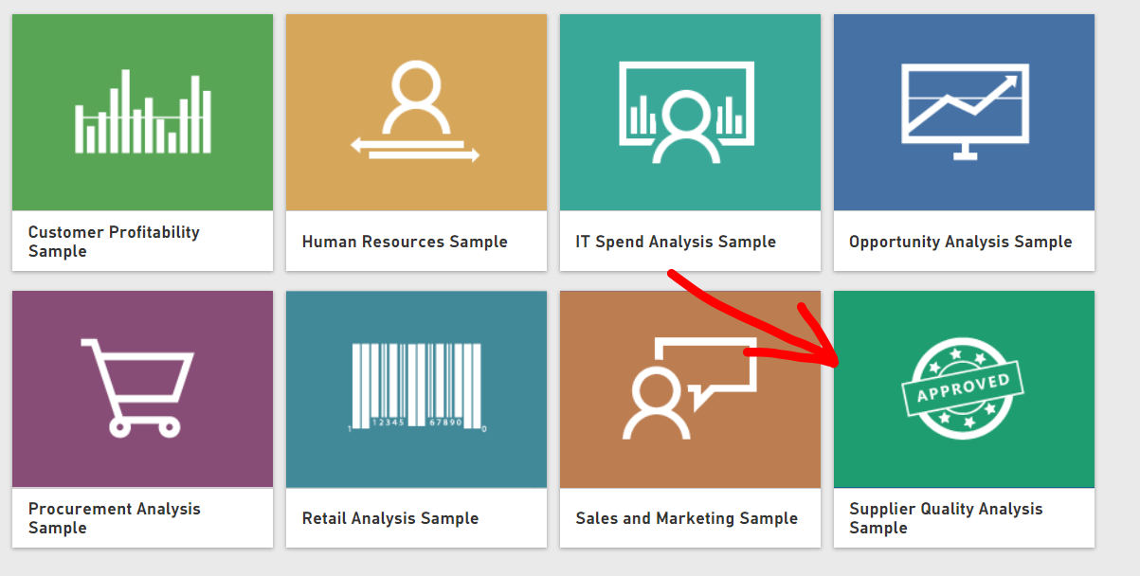

Connect

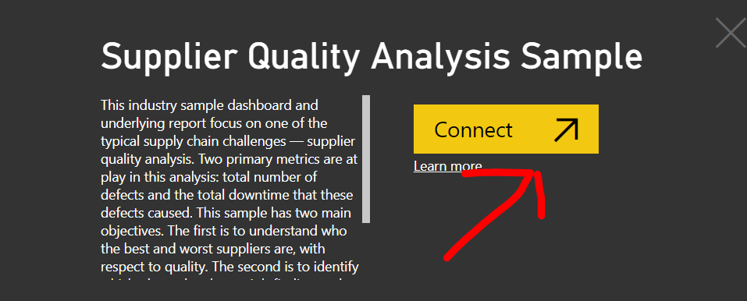

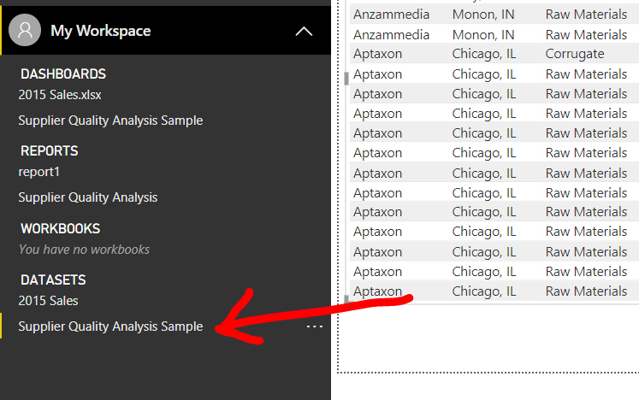Successfully connected

View Dashboard

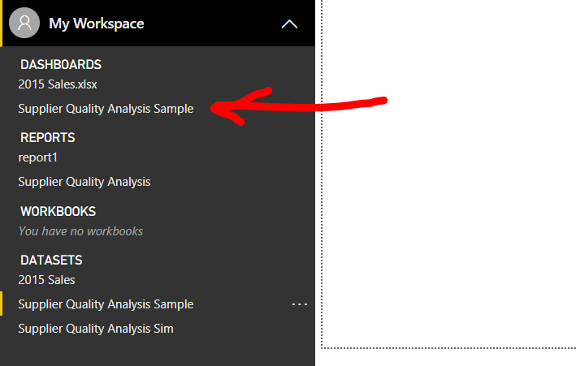

Click Total Defect Quantity

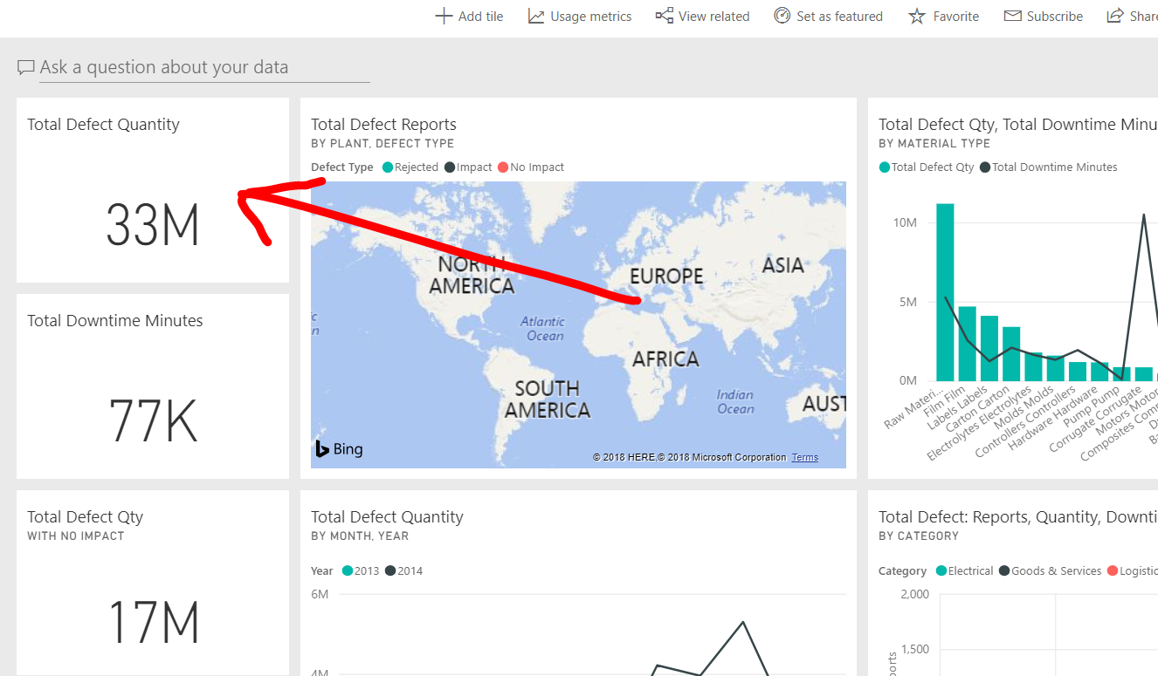

View Downtime caused by defective materials

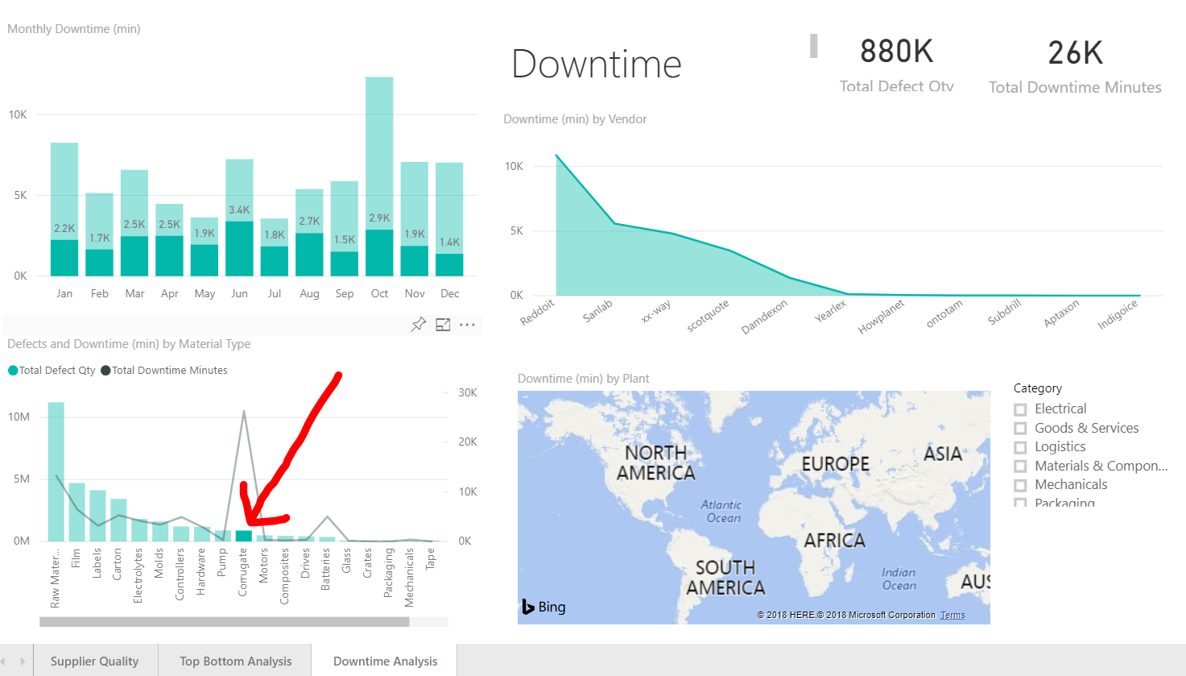

**Introducing Quick Insights**

Introducing Quick Insights

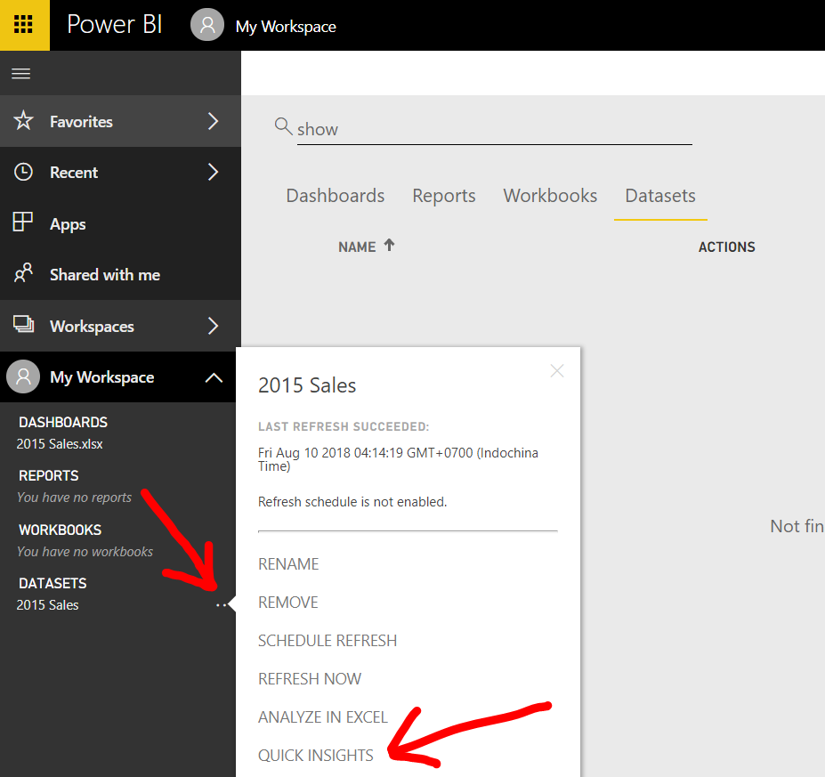

Insights are ready

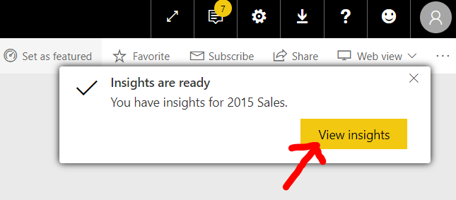

What is insight?

* Use artificial intelligence to analyze your data
* Searching for some useful or interesting patterns
* Very sophisticated algorithms

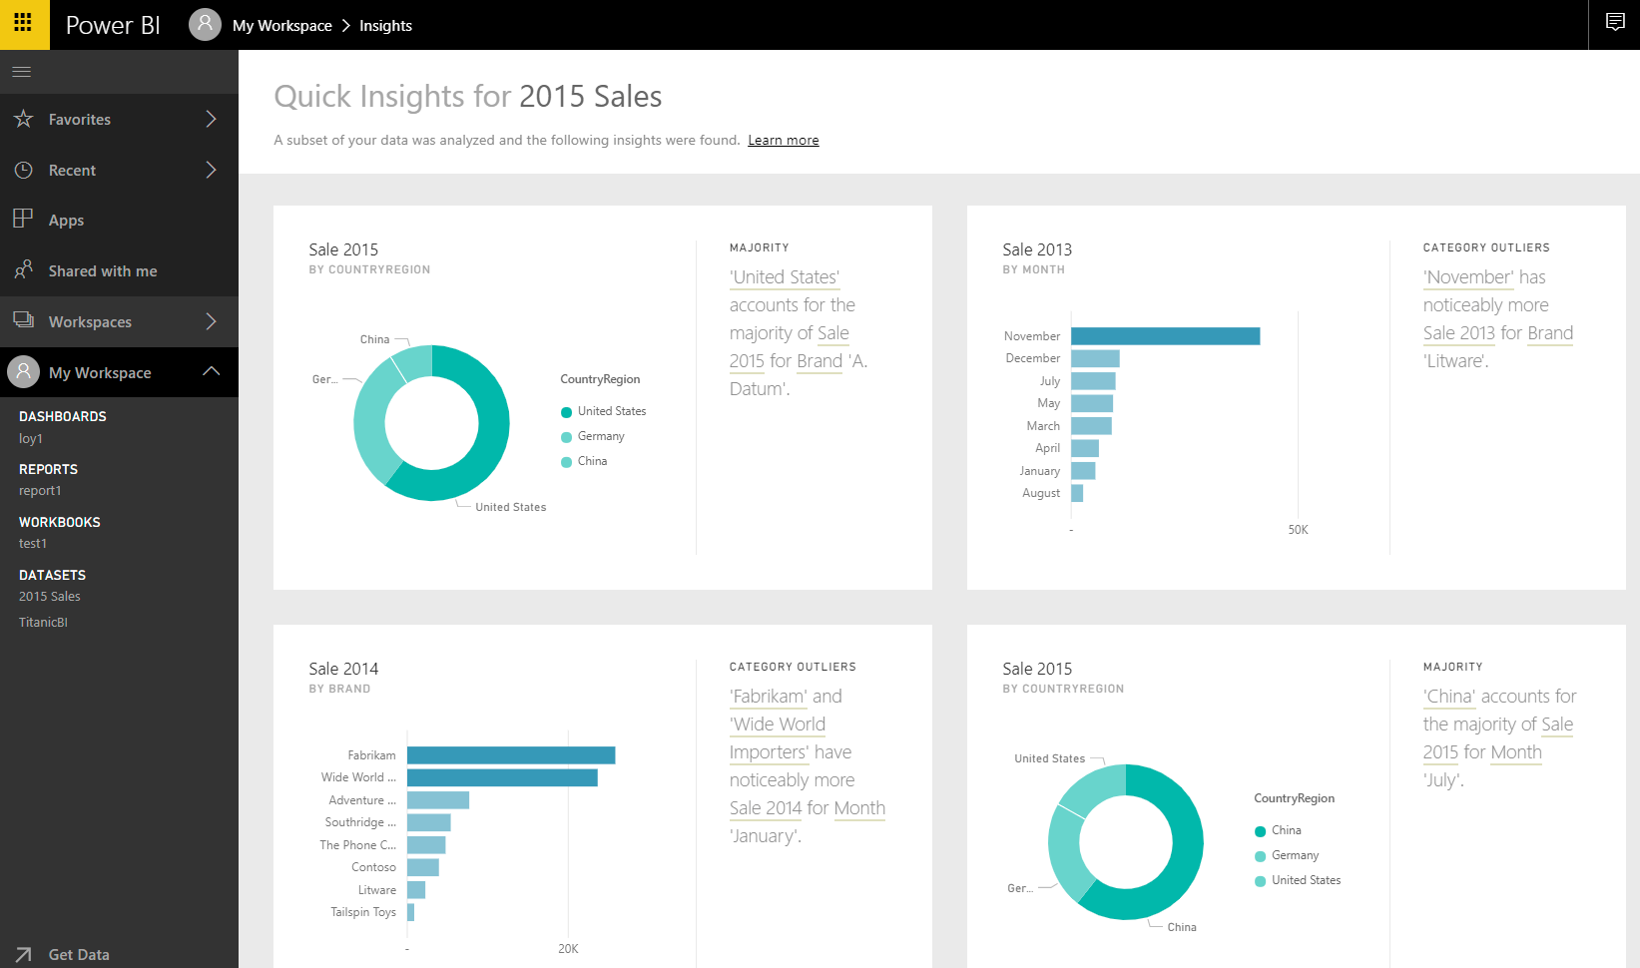

The first insight shows

United States accounts for most of the sales of the A. Datum brand

Compared with China and Germany

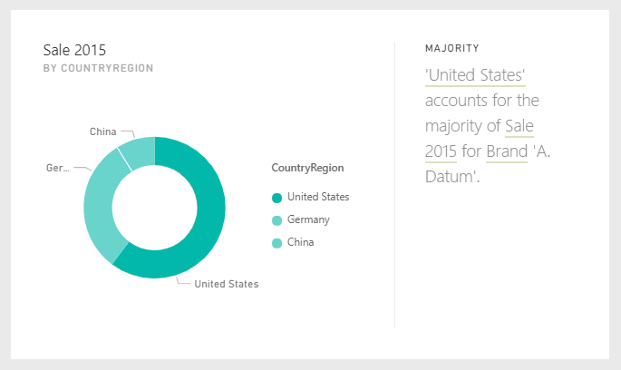

The second insight reveals a substantial seasonal-effect increase

in sales for the month of November 2013 for Litware

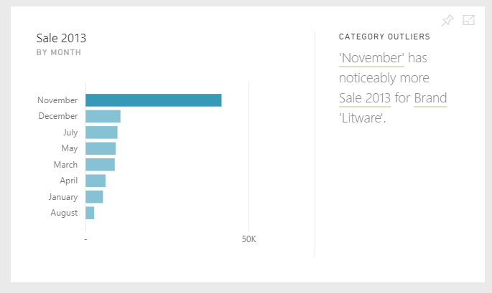

Pin Sale 2013 by month to dashboard

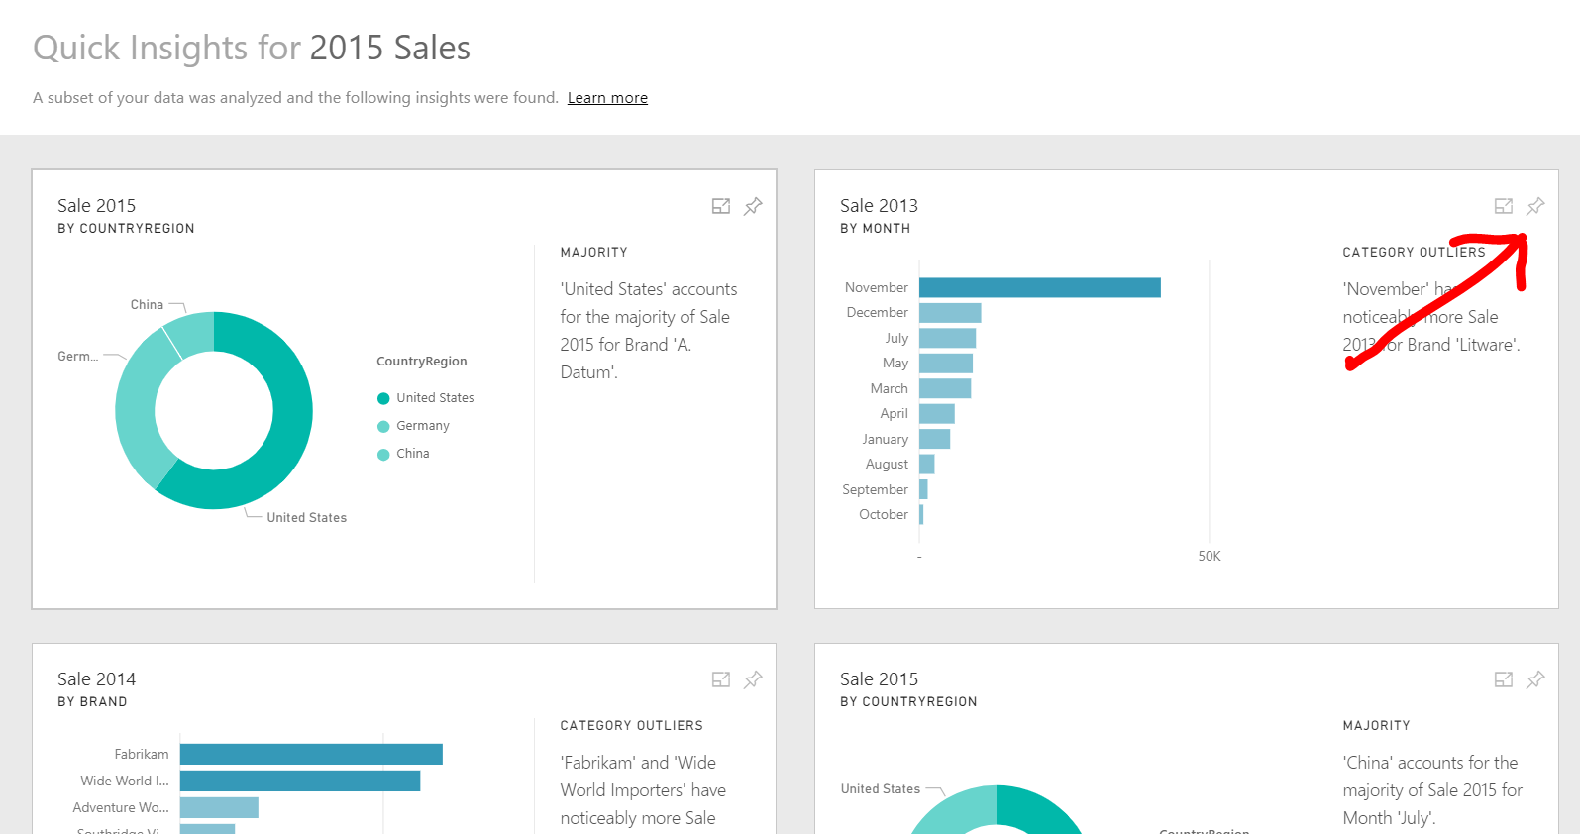

Click Pin

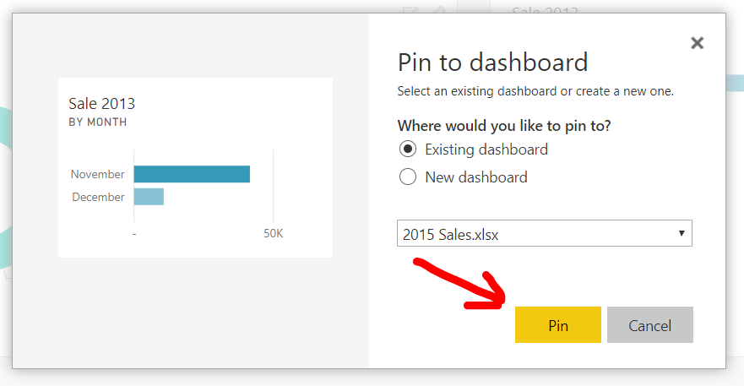

Click DASHBOARDS

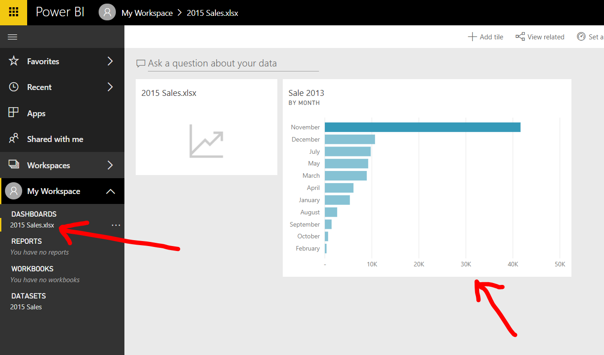

Get Quick Insights from Supplier Quality Analysis sample

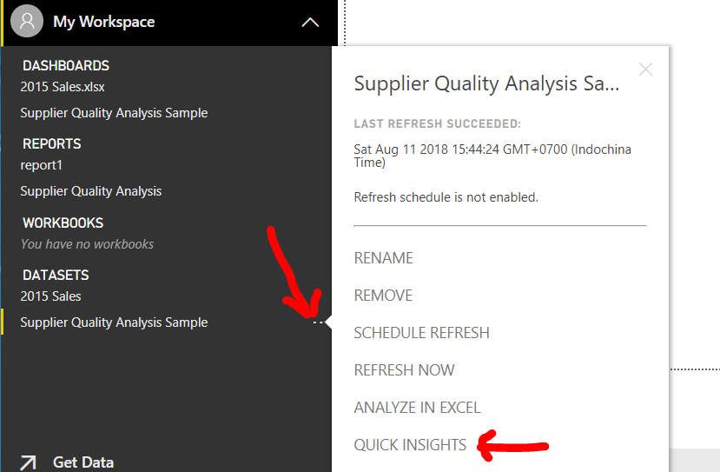

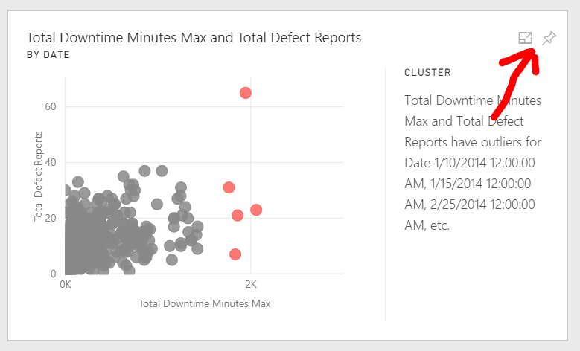Pin insight to new dashboard

Create New dashboard

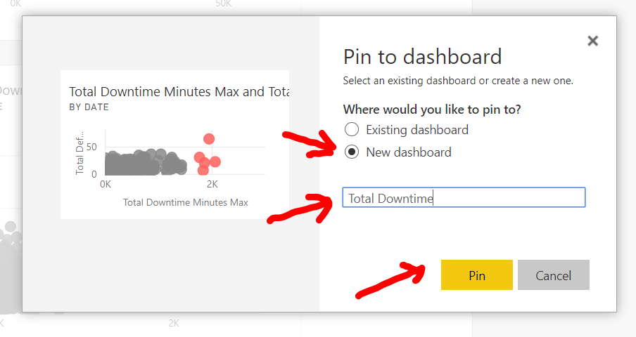

Click Total Downtime dashboard

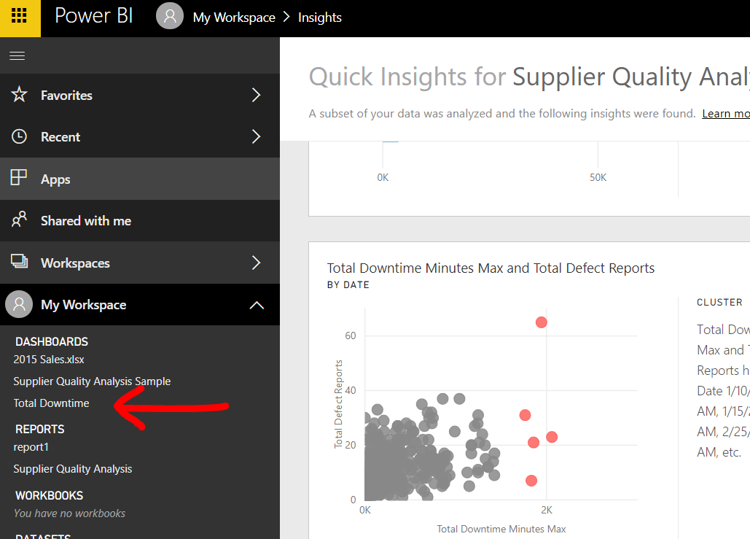

Open in focus mode

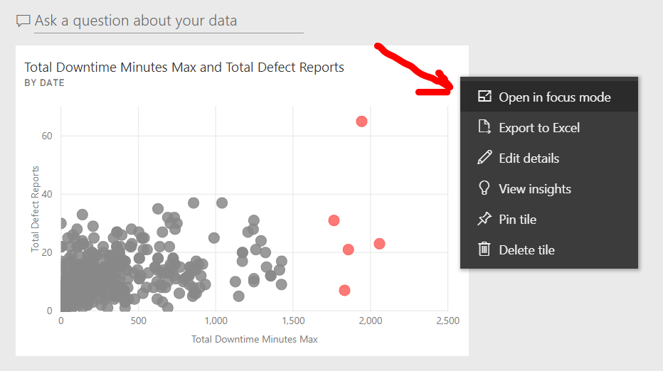

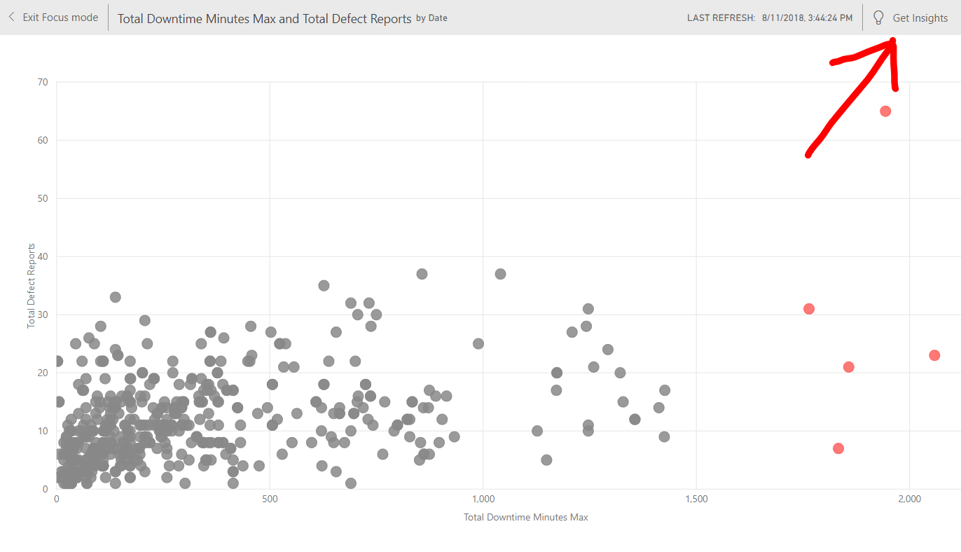Get Scoped Insights

Pin More Quick insight

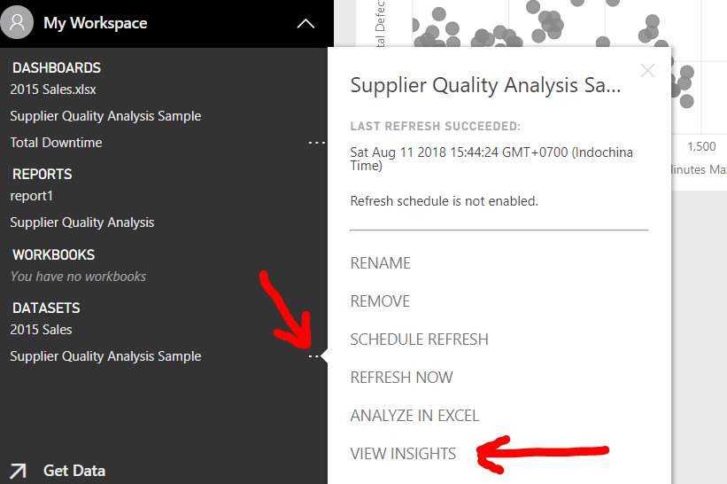

Pin Count of vendor by material type

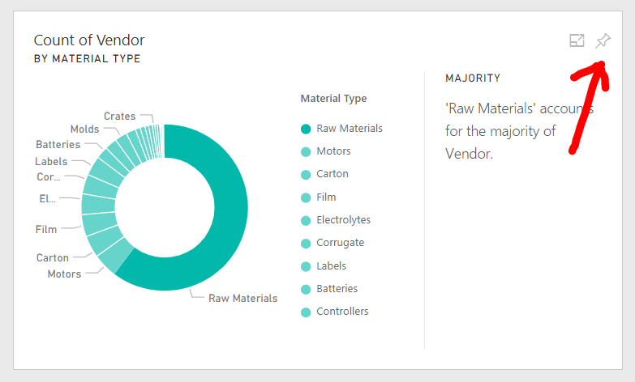

Pin to Total Downtime

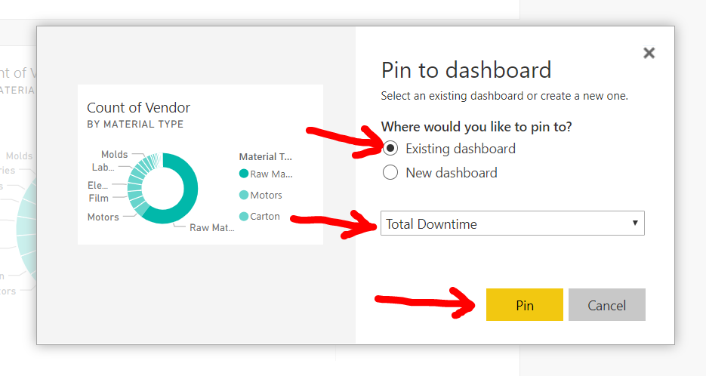

Open Total Downtime

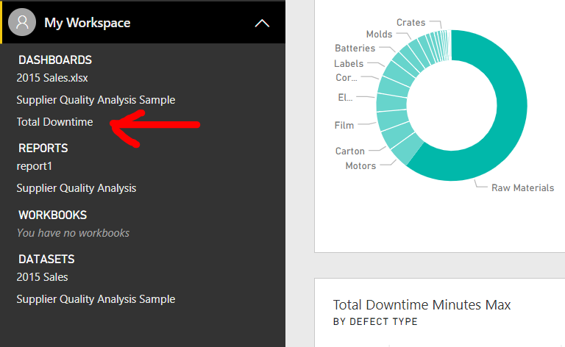

Open in focus mode

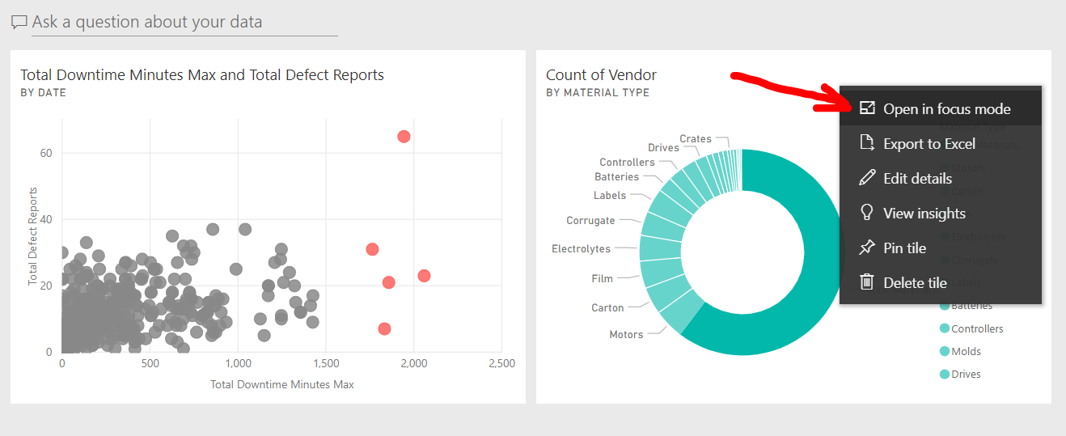

Filter Count of Vendor is greater than 10

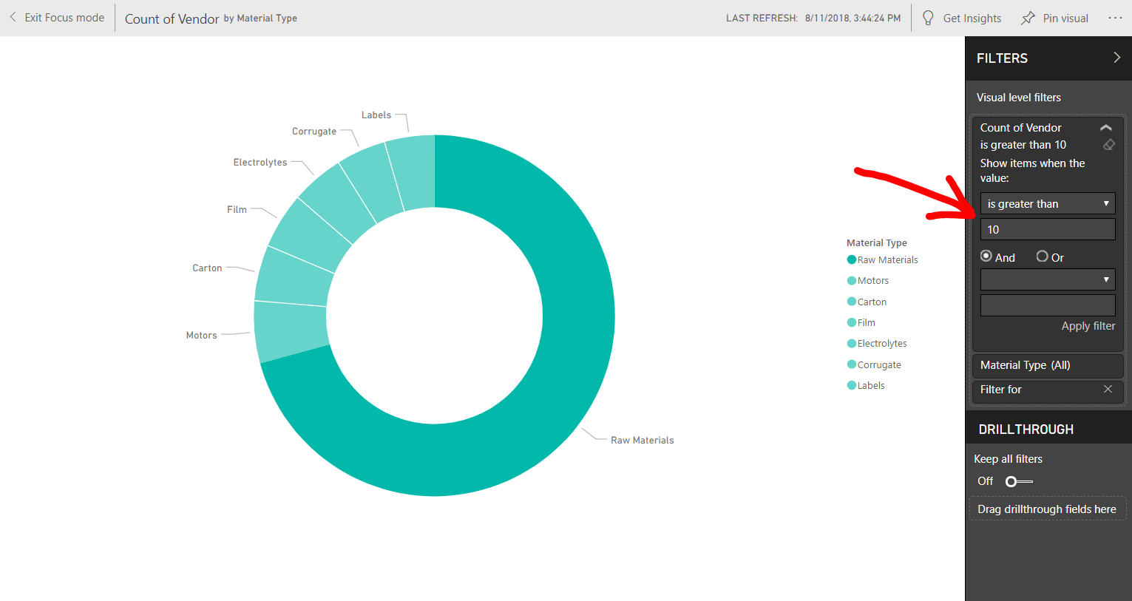

Exercise

* New and Repeat all steps
* Pin multiple quick insights

**Introduction to reports**

Introduction to reports

Click 2015 sales dataset

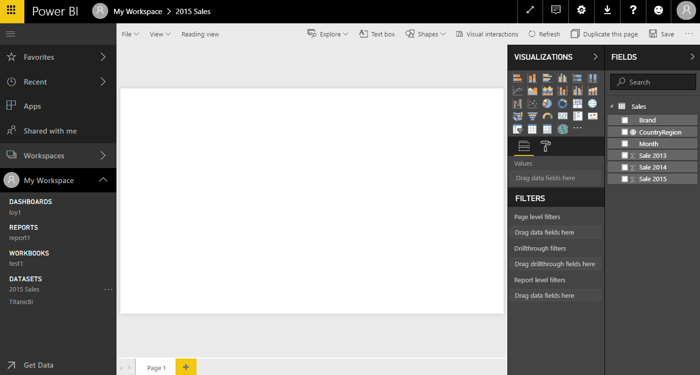

Canvas

Visualizations

Fields

Filters

FIELDS

* 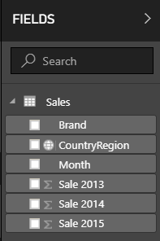Some of them have a small icon beside their names.
* This icon identifies the main usage of the field.
* For example, the fields Sale 2013, Sale 2014, and Sale 2015 each
* have a summarization icon (a Greek sigma), indicating that the total for each column will be displayed if used in a report.
* The CountryRegion field shows a small globe, indicating that this field contains geographical data, and it will be used to draw data on maps.
* Click Brand
* Click Sale 2015

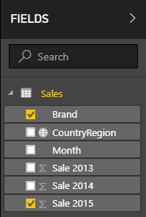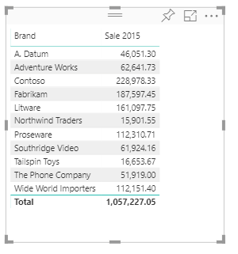

Table is default visualization

Click Stacked bar chart

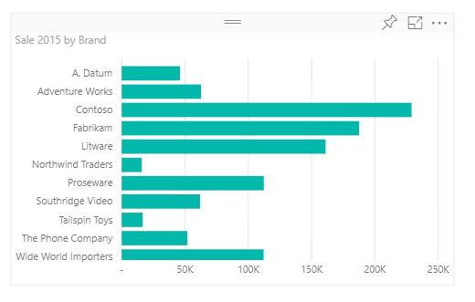 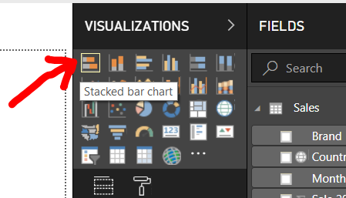

**Creating Map**

Click empty space

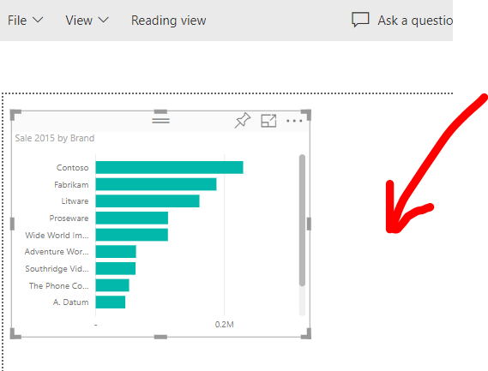

Click Map Icon

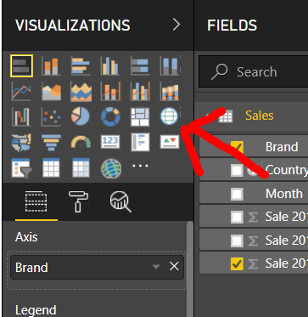

Click Field CountryRegion AND Sales 2015

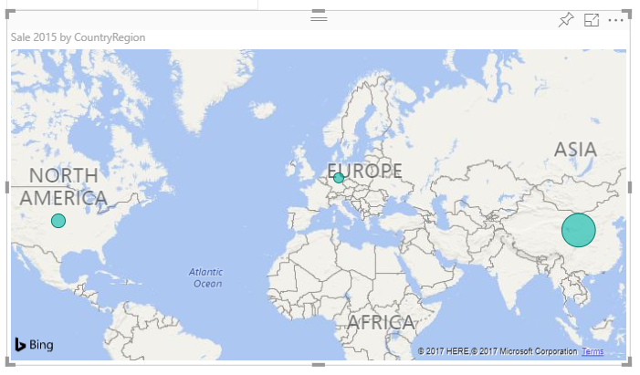

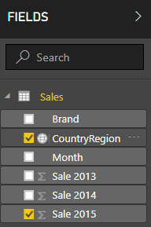

Exercise

* Remove data and repeat all steps
* Create report with pie chart

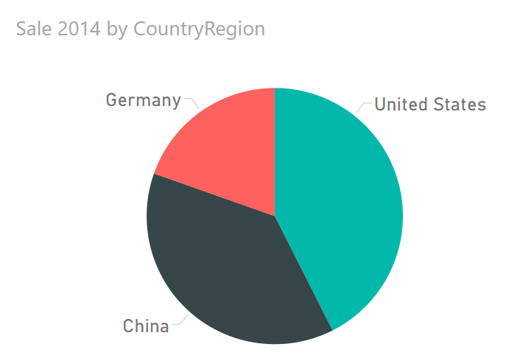

**Introducing to Visual Interactions**

1. Create Sale 2015 by ContryRegion / Stacked column chart
2. Create sale 2015 by Brand / Stacked bar chart

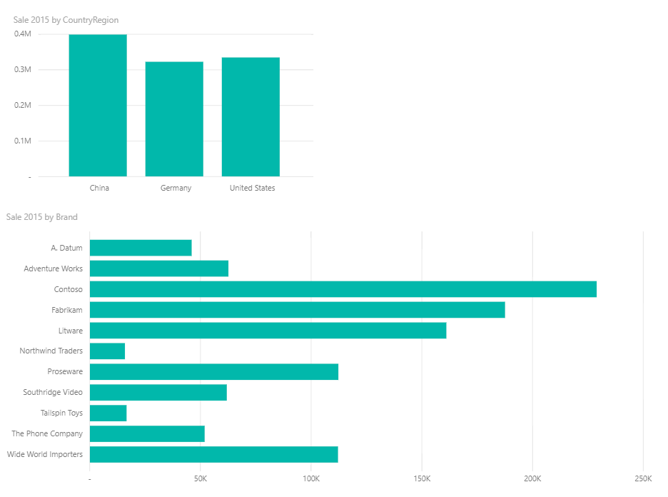

* Click Germany column at the top chart
* Notice changing color of the below chart
* To select more than 1 column press and hold Ctrl key

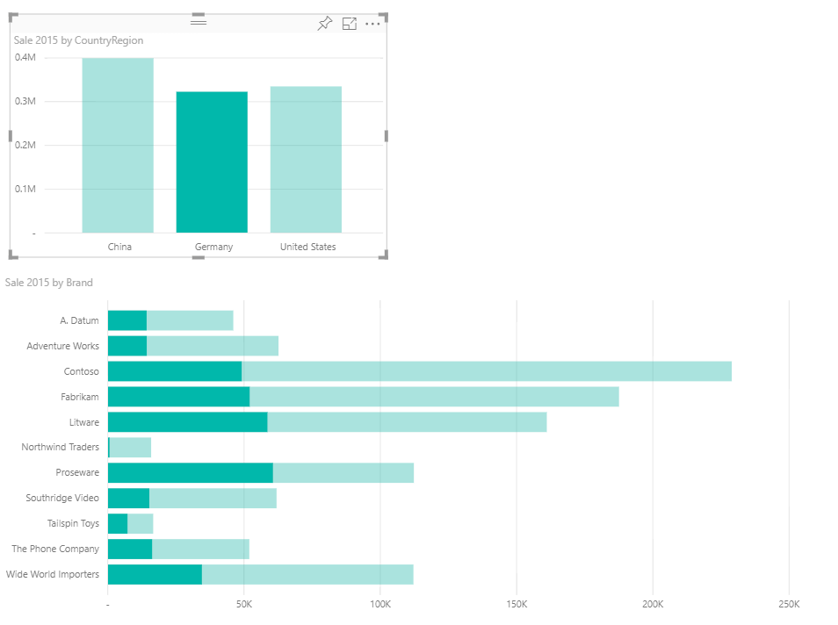

* Click Contoso bar at the below chart
* Notice changing color of the top chart
* To select more than 1 column press and hold Ctrl key

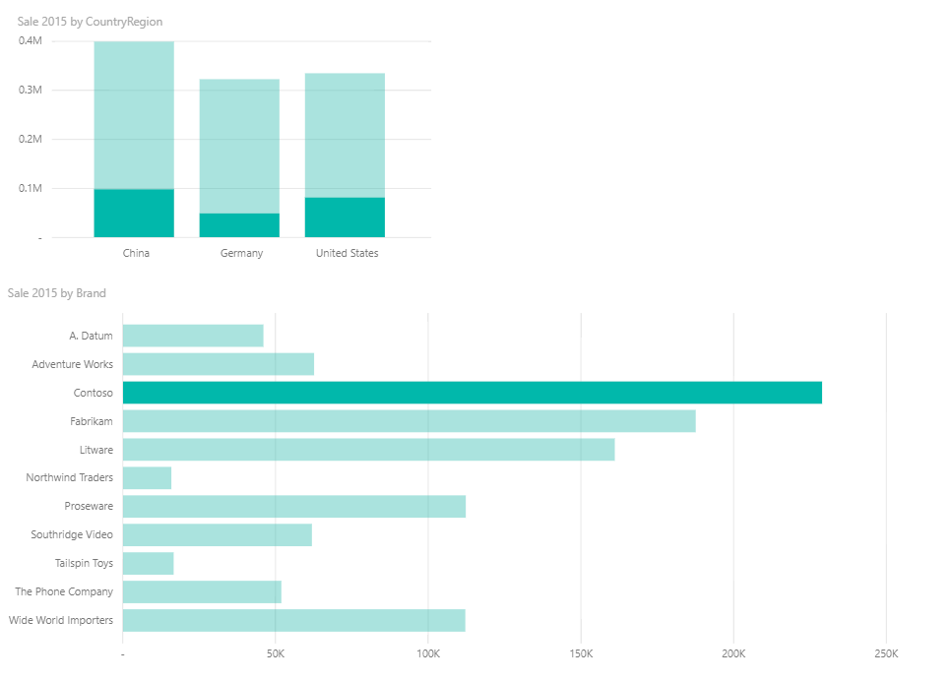

Turn on/off Visual Interactions

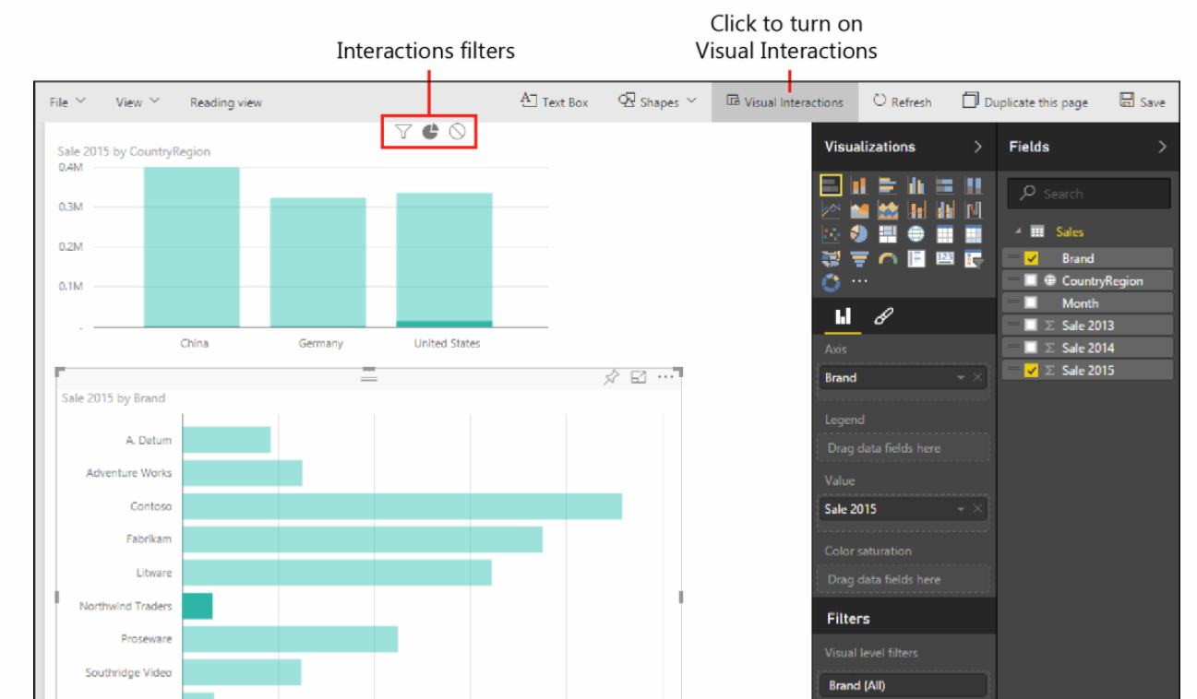

Exercise

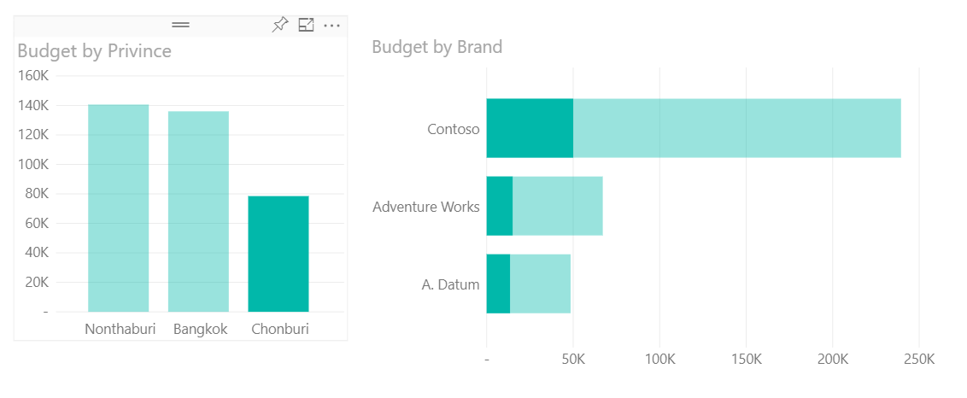Thai Budget.xlsx

**Decorating**

**the report**

Adding text box

* Change font size
* Add border and background color

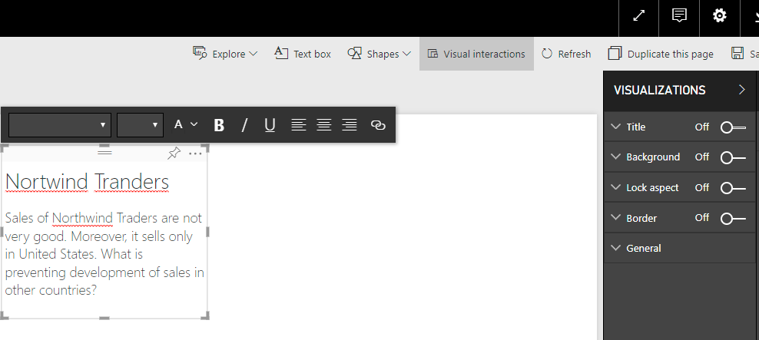

Adding arrow

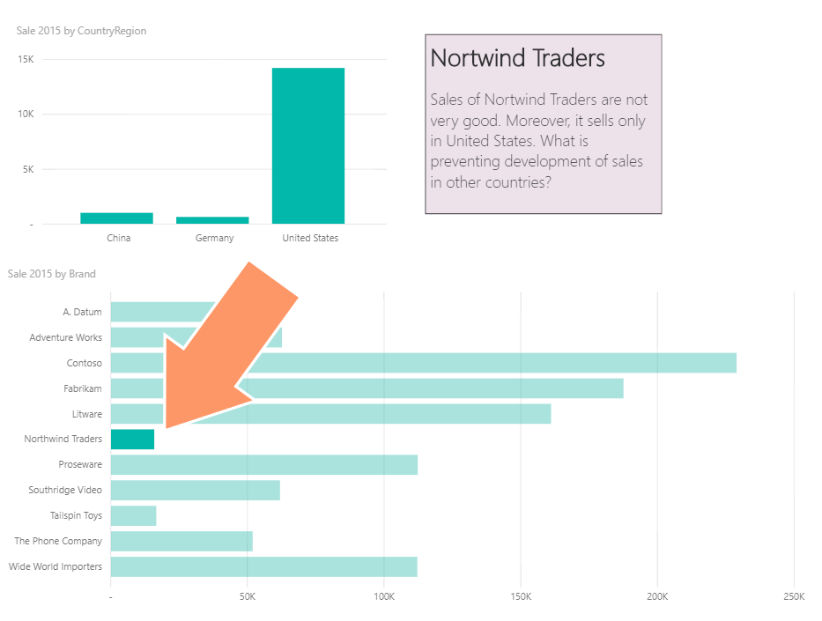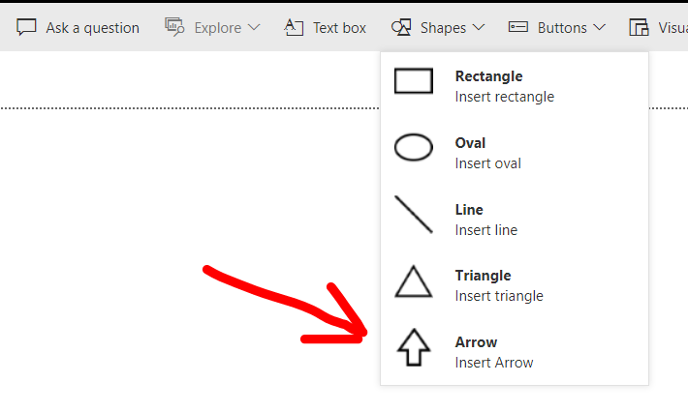

Saving the report

Report name = Northwind Trader

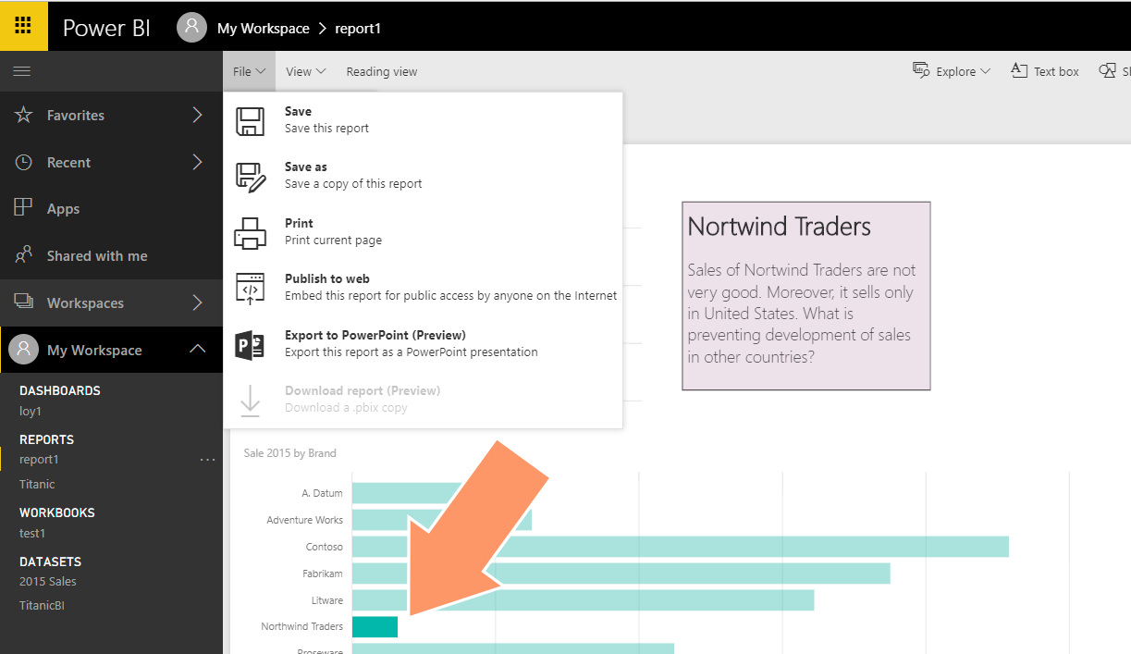

* After you save the report, it appears in the My Workspace pane, in the Reports section.
* You can now access it any time you sign in to Power BI.
* When you select a saved report, it opens and remains in read-only mode until you explicitly activate it for editing by clicking the Edit Report button.

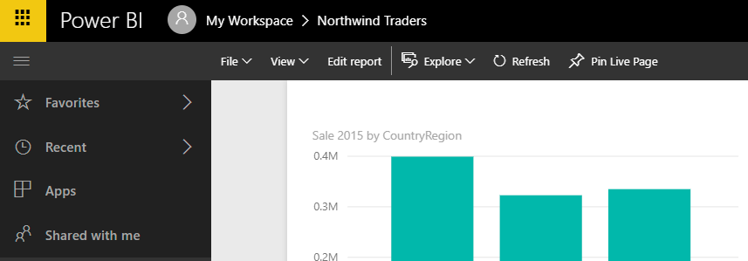

Pinning a report

Click to pin a report as a live page

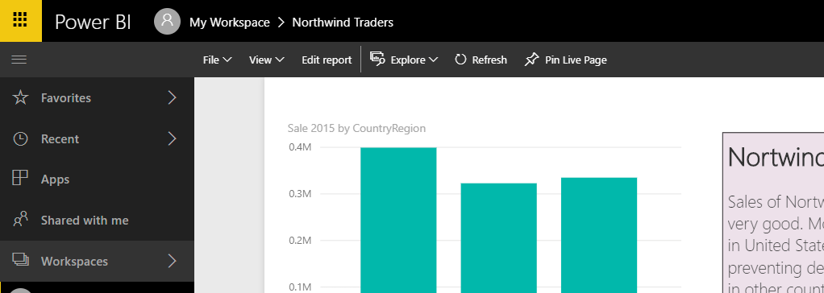

Pin Visual VS Pin Live Page

Pinning a visualization

* Power BI saves it as it is
* Not include the visual interactions
* Click a visualization to open the source report

Pinning Live Page

* Keep visual interactions between components
* Click Live Page will not open the source report

Exercise

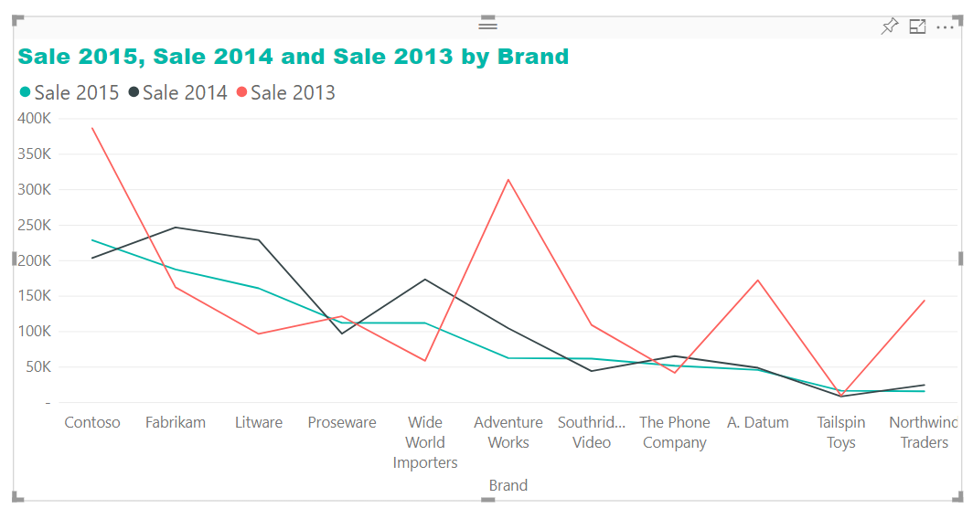

**Refreshing the budget workbook**

Refreshing the budget workbook

* How he will refresh his data when new figures become available
* He began building the budget in October
* New data will be arriving over time
* Sales and the country/region managers will provide new forecasts
* David will need to add to his workbook
* How will he upload new data to refresh the existing data?
* Country/region managers send update data
* Forecast base on the brand
* No monthly detail
* This forecast is at year level

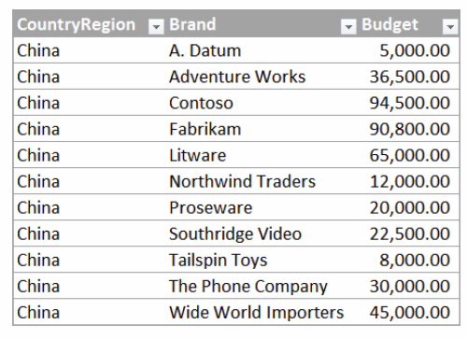

Make budget with forecast

* The workbook with the new Budget column
* Numbers do not reflect the seasonal nature of sales
* Number are not correct.
* We will fix this and use a better technique later

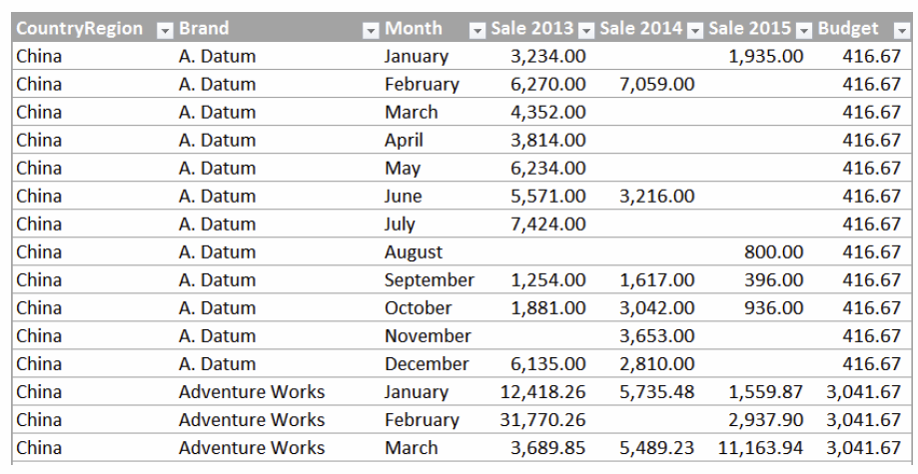

* Download file : Sales and Budget Manually Combined.xlsx
* Change name to 2015 Sales.xlsx

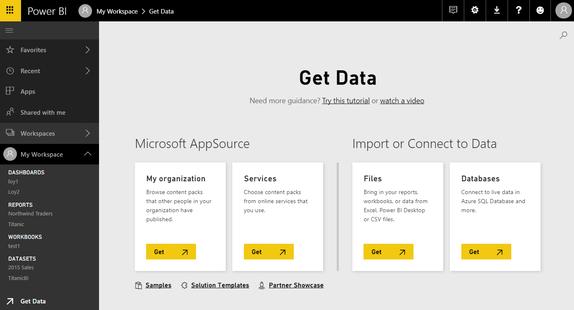

Local File, Import, Replace it

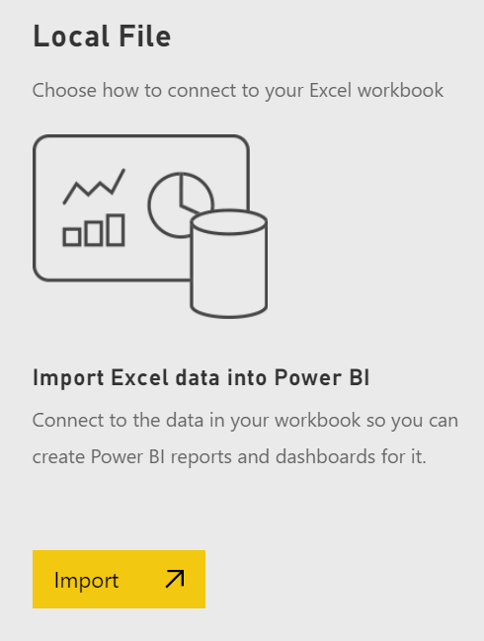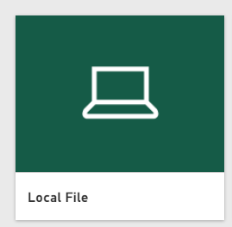

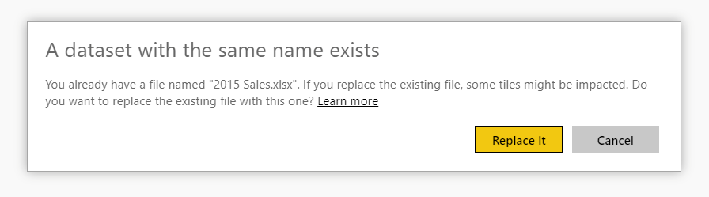

Add new page to report

* 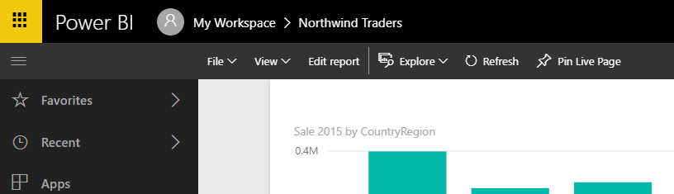Click report
* Click Edit report
* Click + to add Page 2

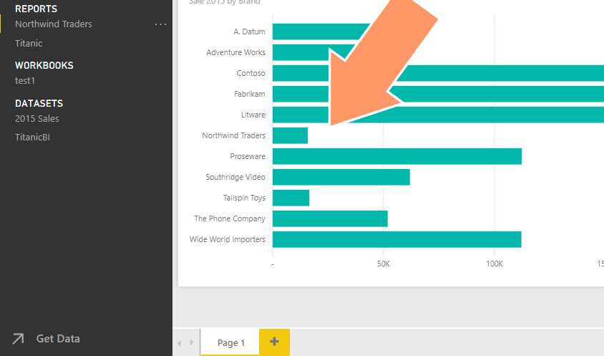

Budget and Sale 2015 by Brand

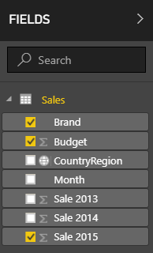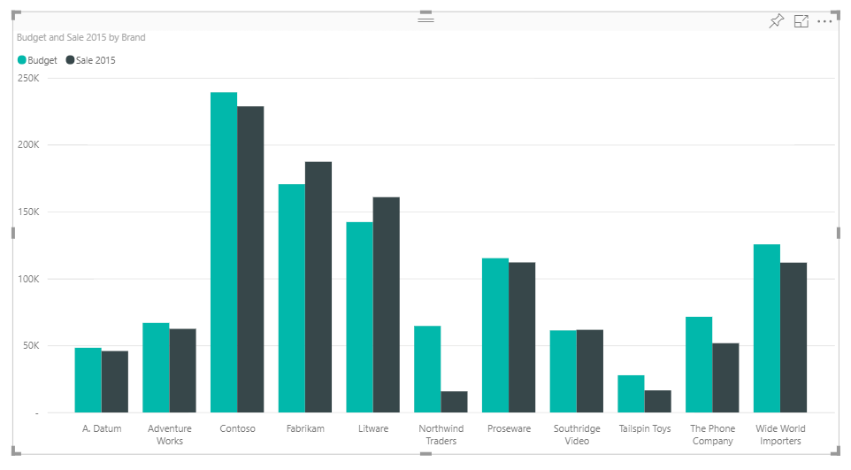

Clustered column chart

Sorting

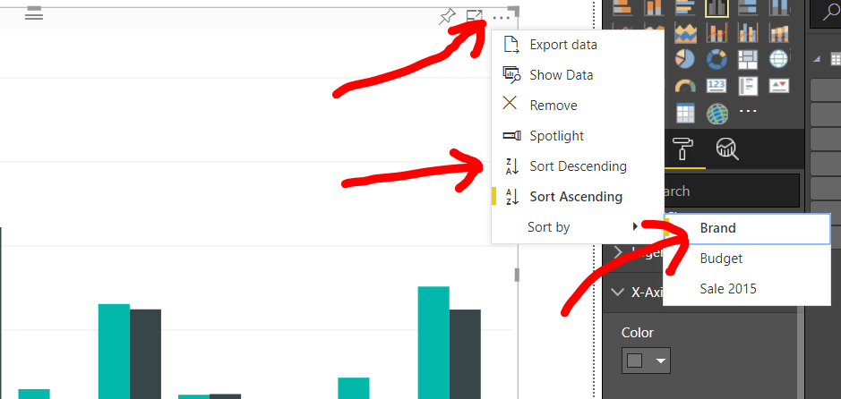

Change Title font size

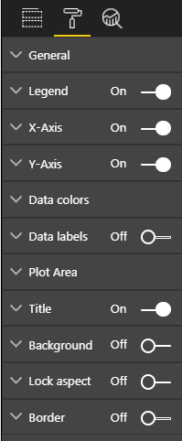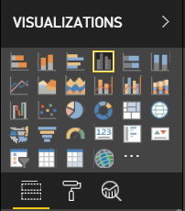

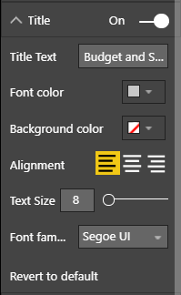

Click format

Add Budget and Sale 2015 by CountryRegion

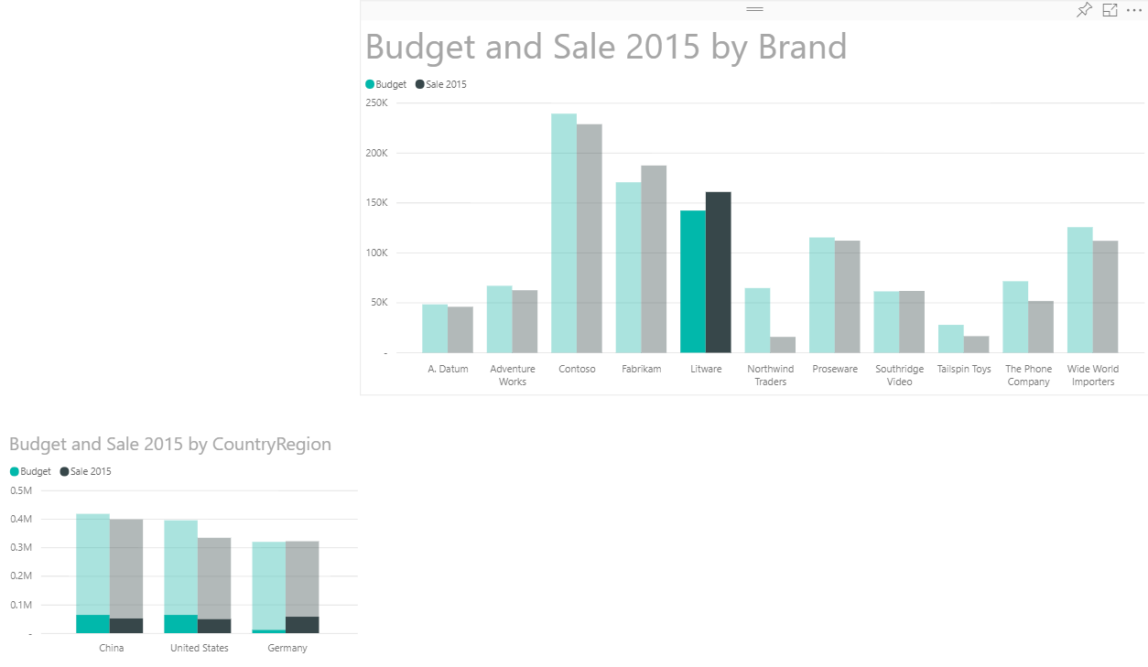

Add filter by brand

* Copy and pates to create new chart
* Change title to Sale and Budget byCountryRegion filtered by Brand
* Change Visual Interaction to Filter

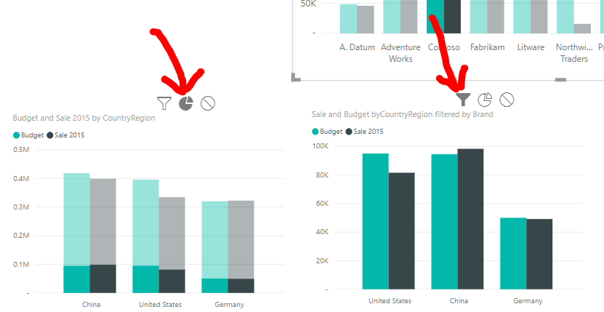

Filtering a report

Visual interactions:

* The filter is not saved as part of the report
* The filter is always visible

Standard filters:

* Visual-level filters: work on only an individual visualization
* Page-level filters: work at the report-page level
* Report-level filters: works on the entire report

Add page level filter to show only China and Germany

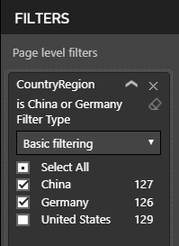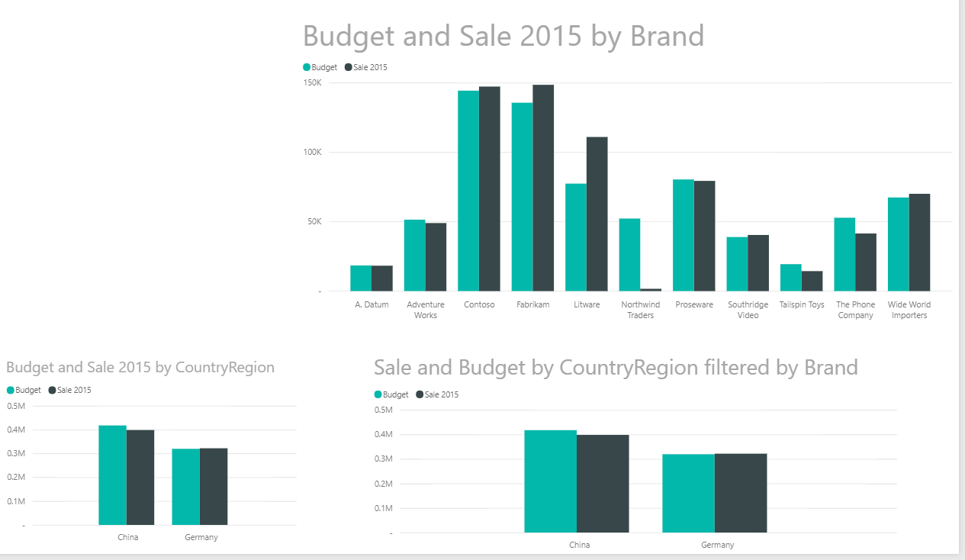

Add Visual-level filters to show only Sale greater than 50,000

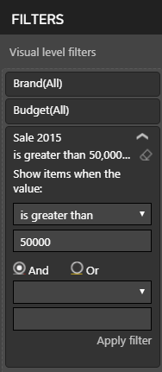

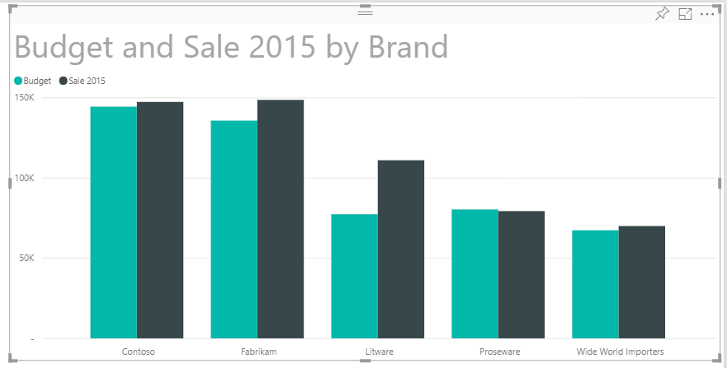

Exercise

Add Donut charts to the report

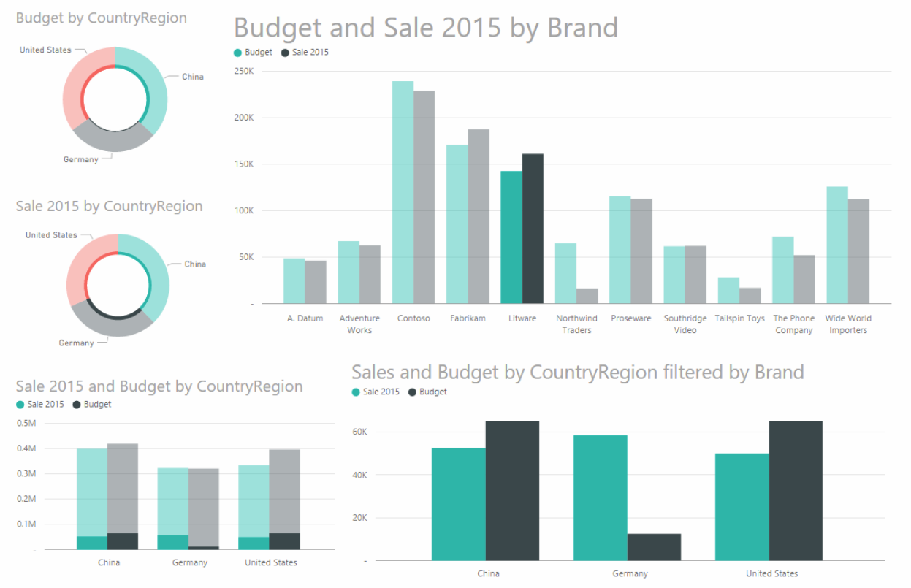

**Sharing and Publish Report**

**Sharing the dashboard**

* Inviting a user to see a dashboard
* Creating a group workspace in Power BI
* Turning on sharing with Microsoft OneDrive for Business
* Viewing reports and dashboards on mobile devices

Inviting a user to see a dashboard

Click dashboard and Share

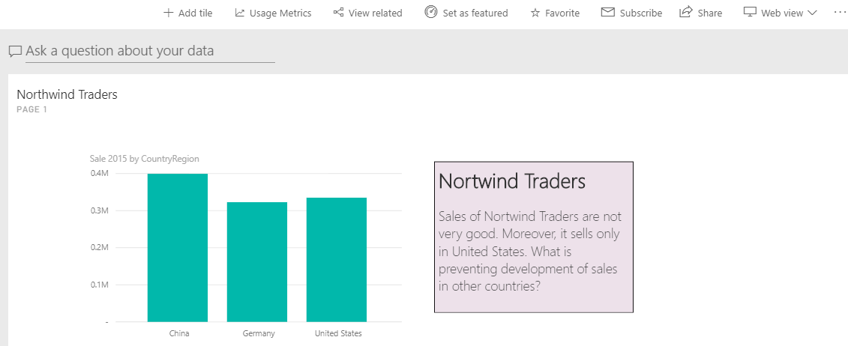

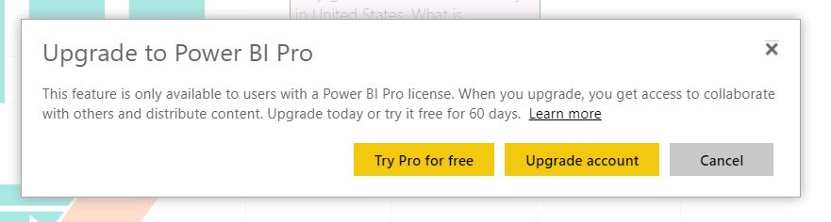

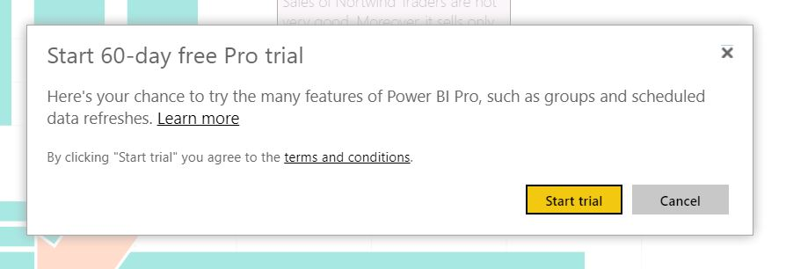

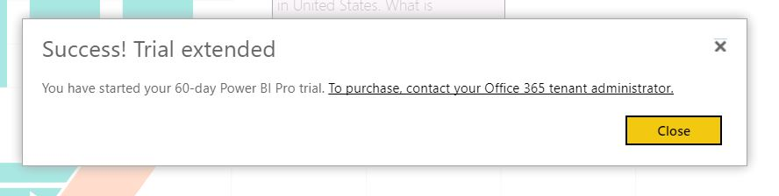

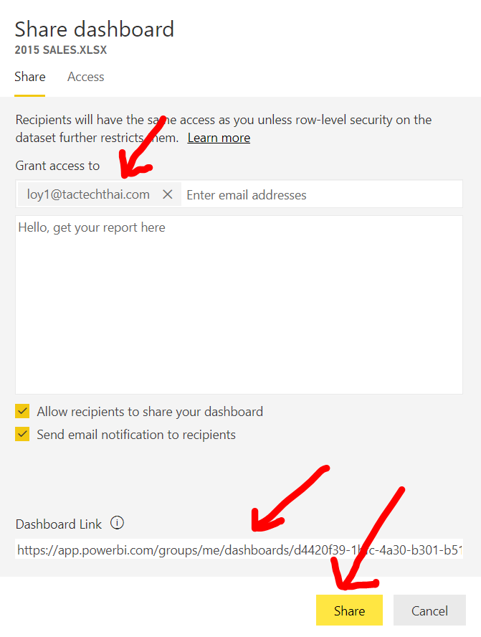

Check mail

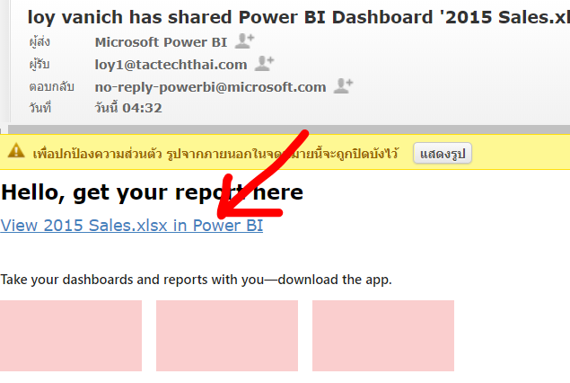

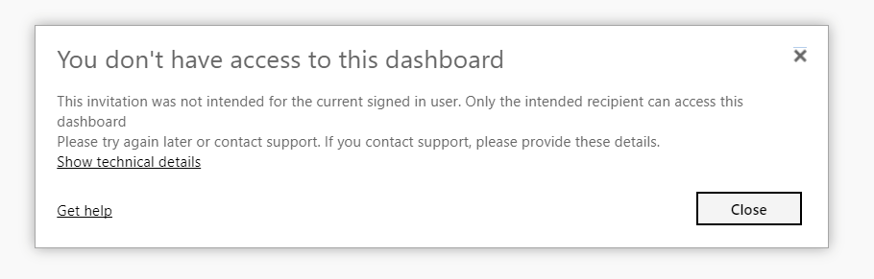

Inviting users outside your organization

* Internal users You can invite internal users to share a dashboard by email or by sending them the URL of the dashboard. In the latter case, users must be authorized. If a user does not have authorization, she can ask for permission when she clicks the dashboard URL.
* External users You can share a dashboard with external users only by inviting them by email. When an external user receives the email, she must sign in to Power BI using the same email account used in the invitation. If she never previously used Power BI, she can create a free account the first time she signs in.

Publish a report

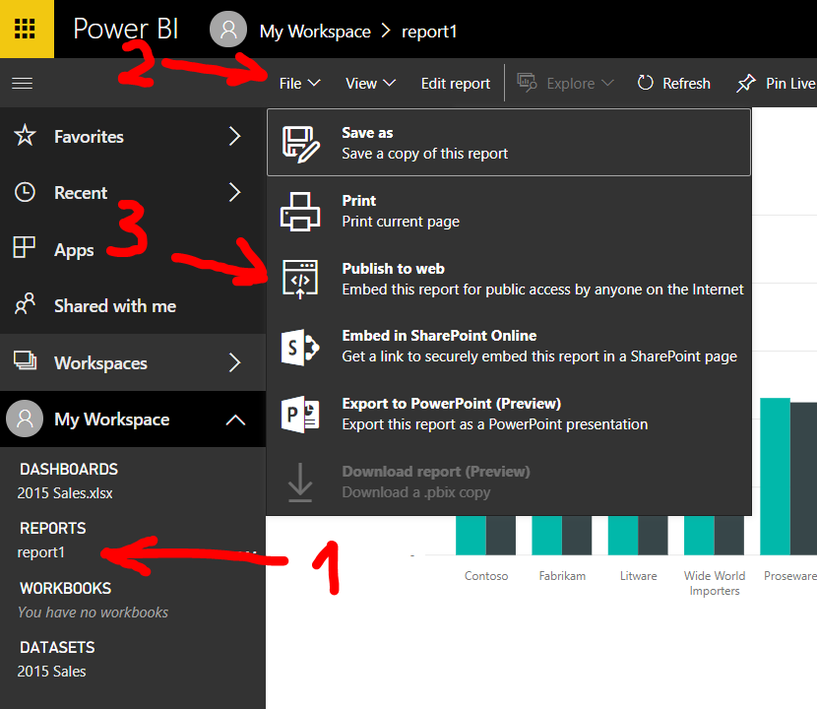

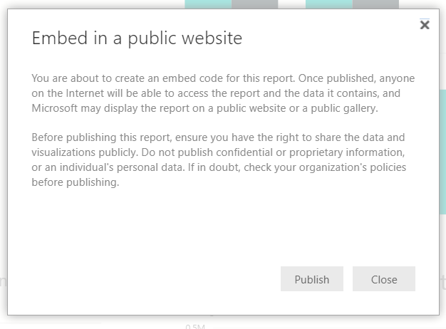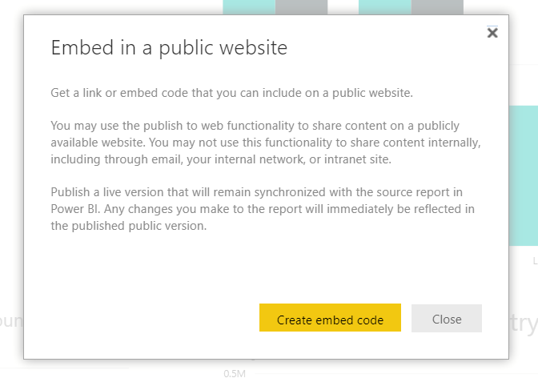

Copy Link and open in new browser tab to view report

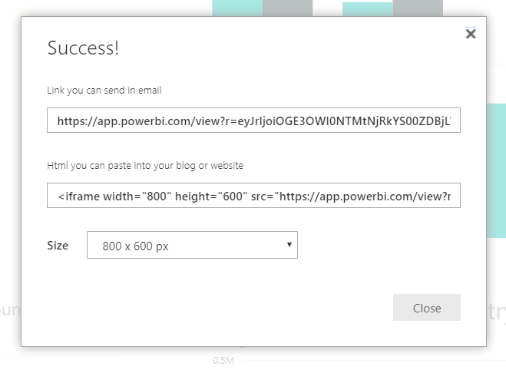

Anyone who has the URL can view your data

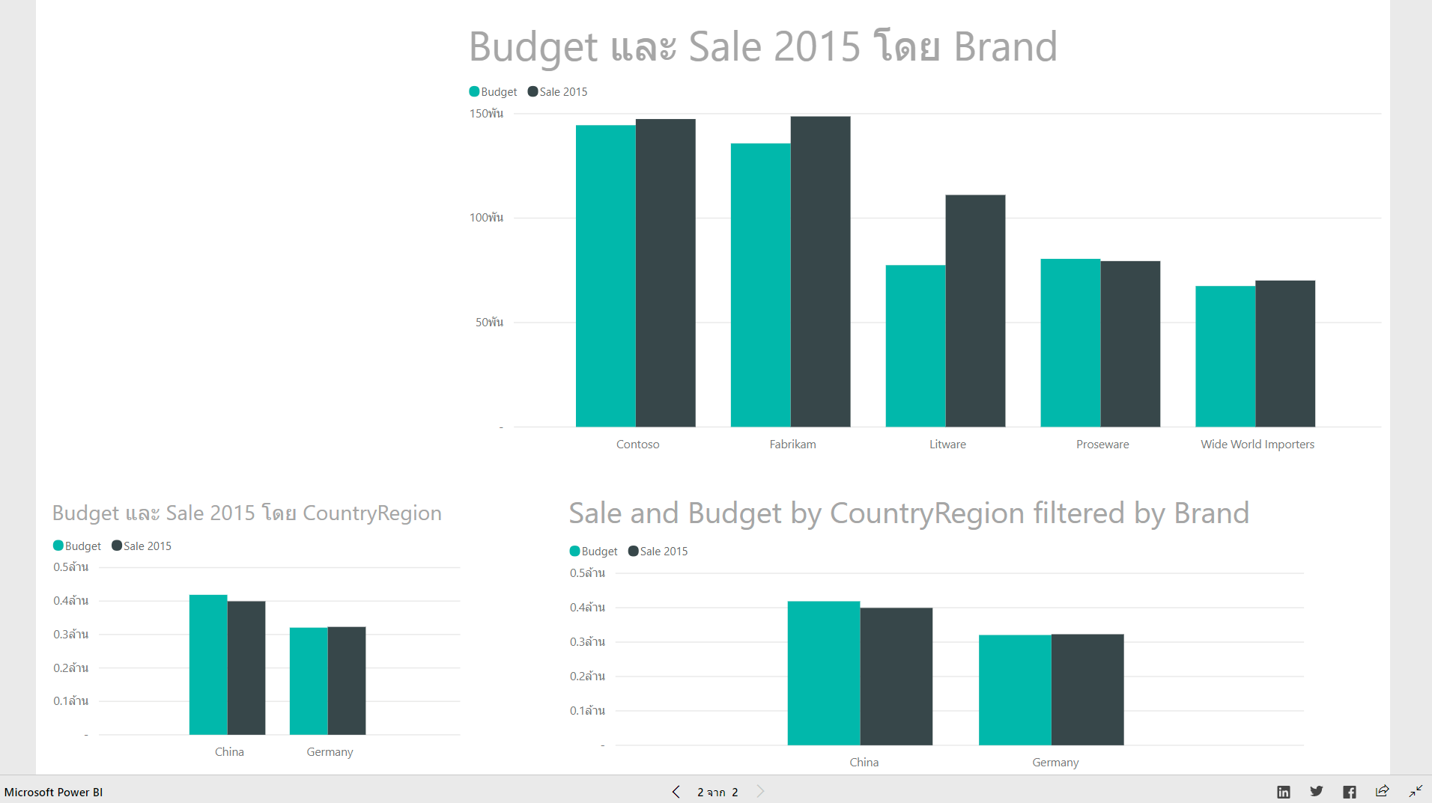

Exercise

* Create this repot from Supplier Quality Analysis Sim.xlsx
* 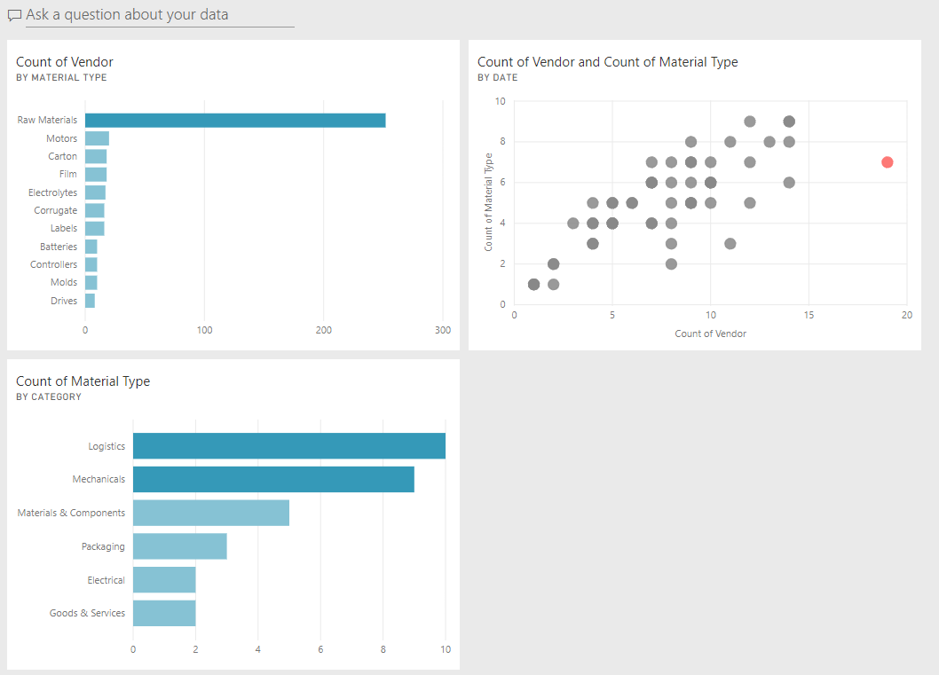Pin to dashboard
* Publish

**Creating a group workspace**

Creating a group workspace in Power BI

* He will need to repeat the same share operation for every dashboard he creates
* When new person join. He will need to send the invitation for all of the dashboards he shares with the group.
* Good news. He can create a group of users with whom he can automatically share all of his dashboards
* And also provide editing rights to certain users within that group.
* By creating groups of users in Power BI, you increase the level of collaboration among them.
* You must have a Power BI Pro license to create group workspace

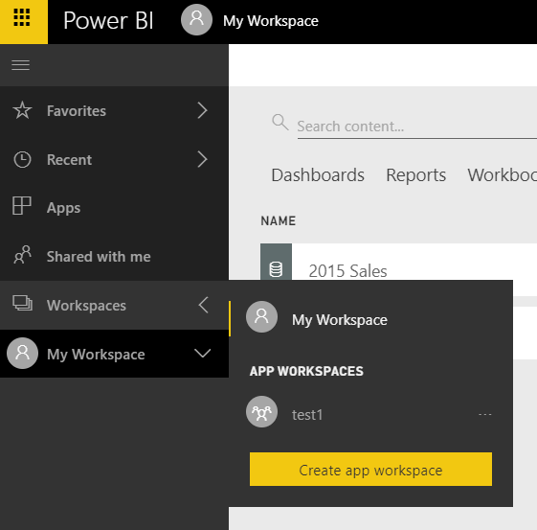

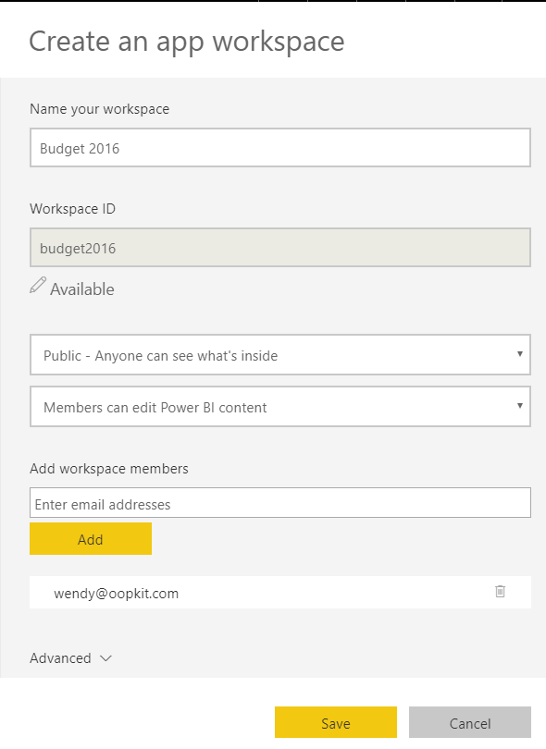

* We must create group before import and create report
* Import data to this group
* Create Report for this group

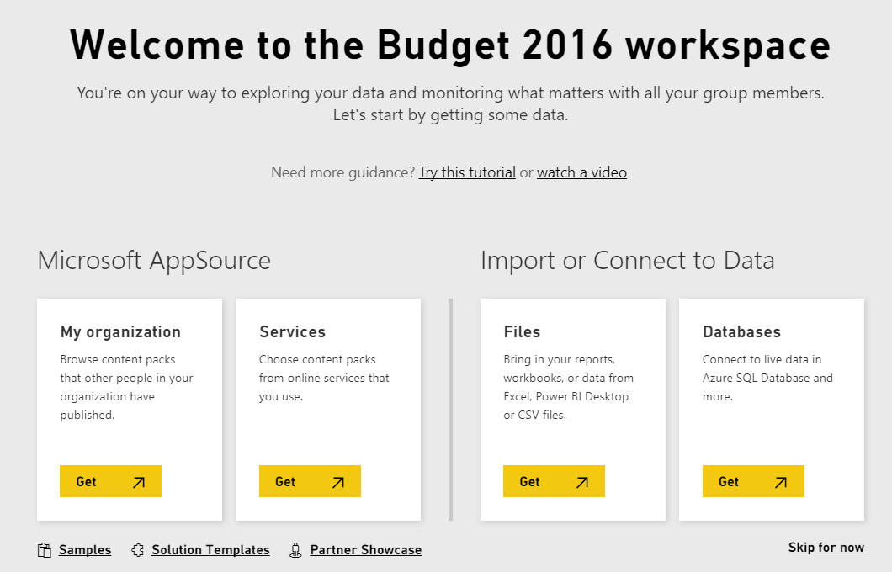

**Power BI Desktop**

Download Power BI Desktop

<https://powerbi.microsoft.com/en-us/desktop/>

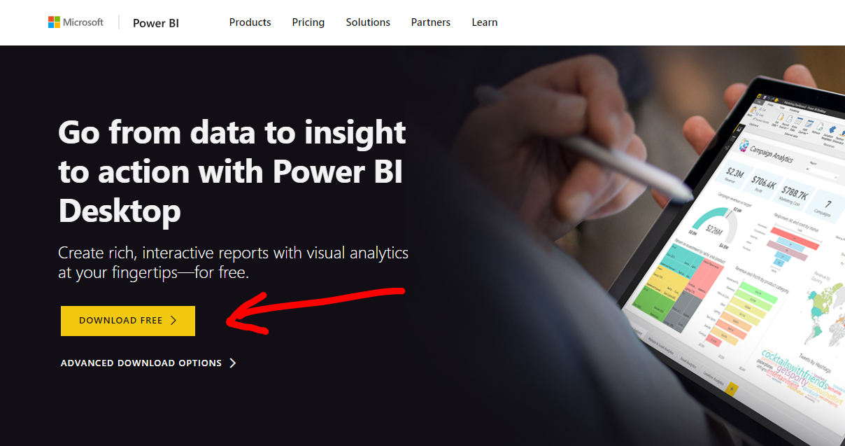

Click to install

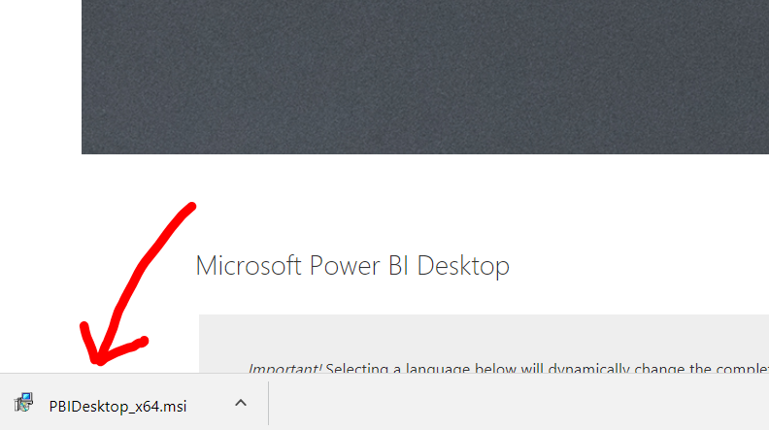

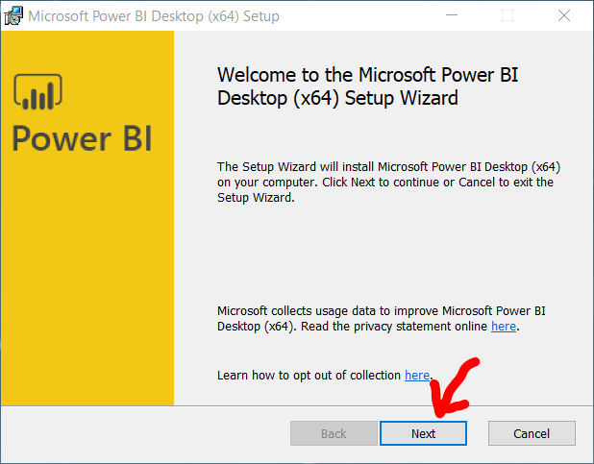

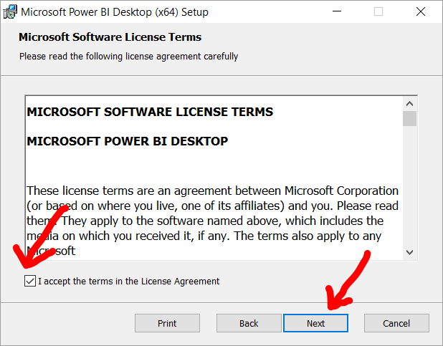

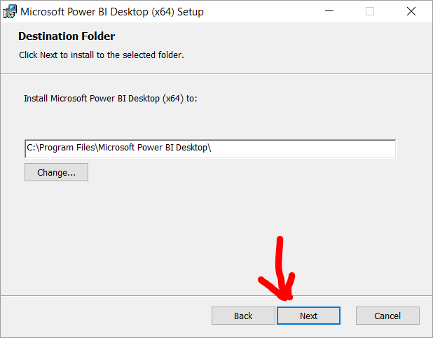

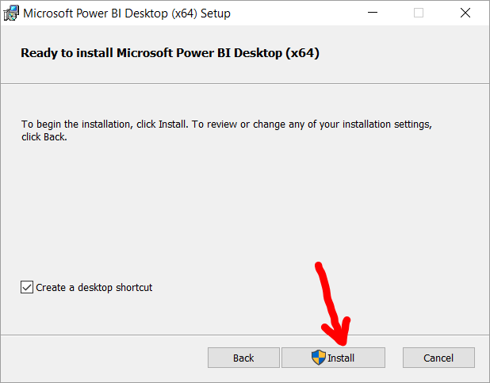

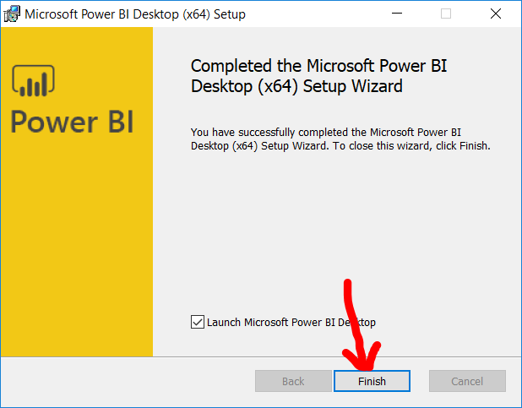

Already have a Power BI account? Sing in

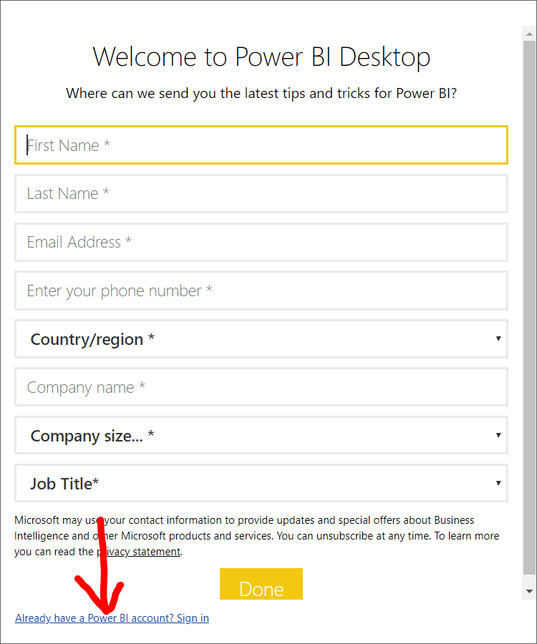

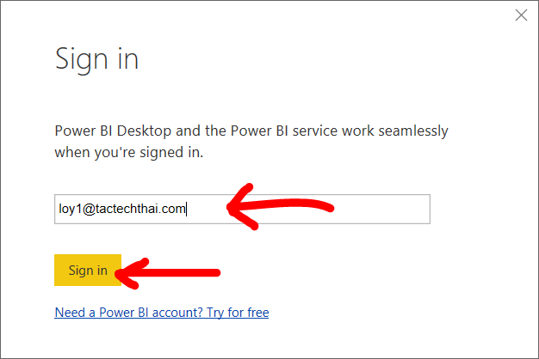

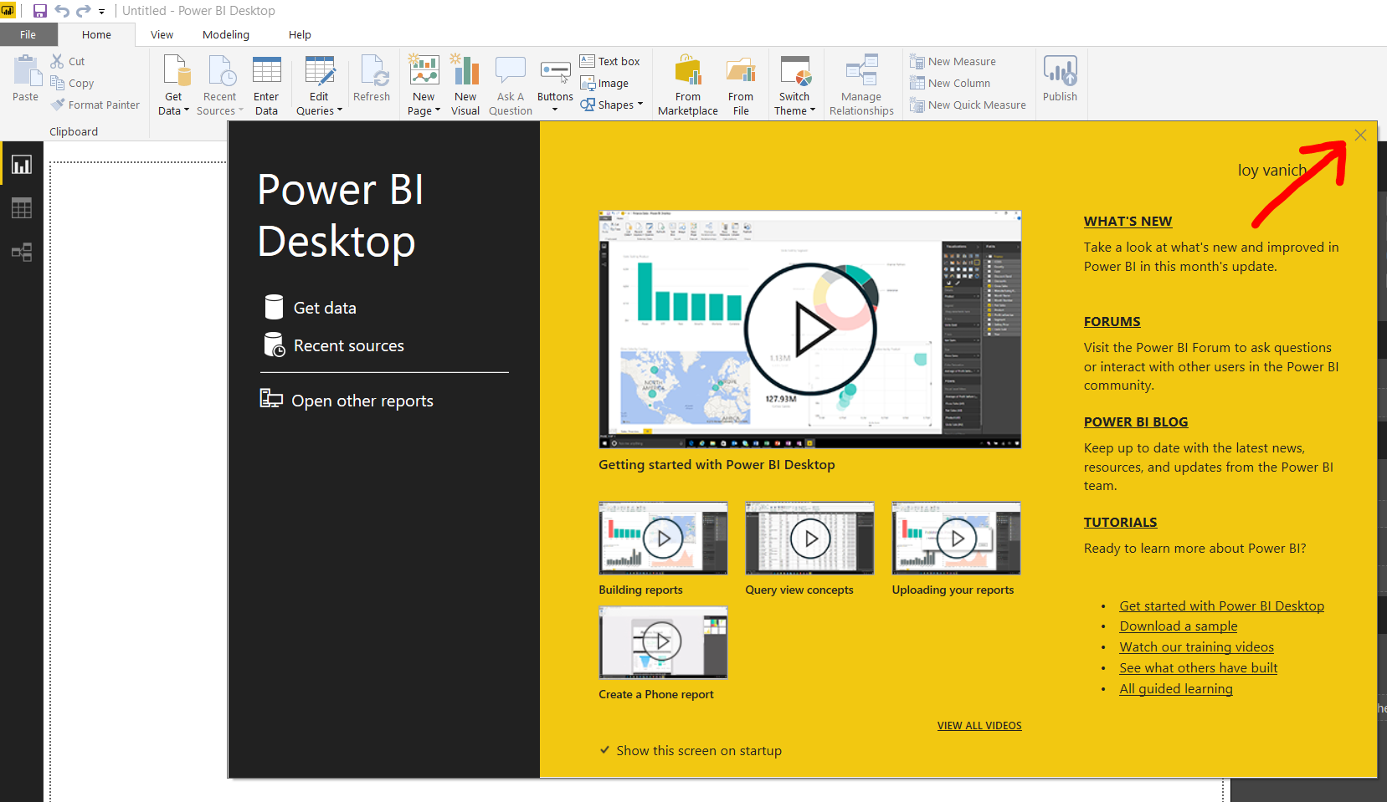

Get Data

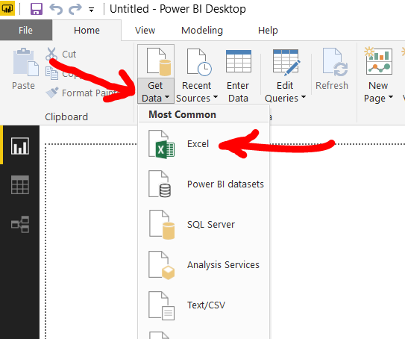

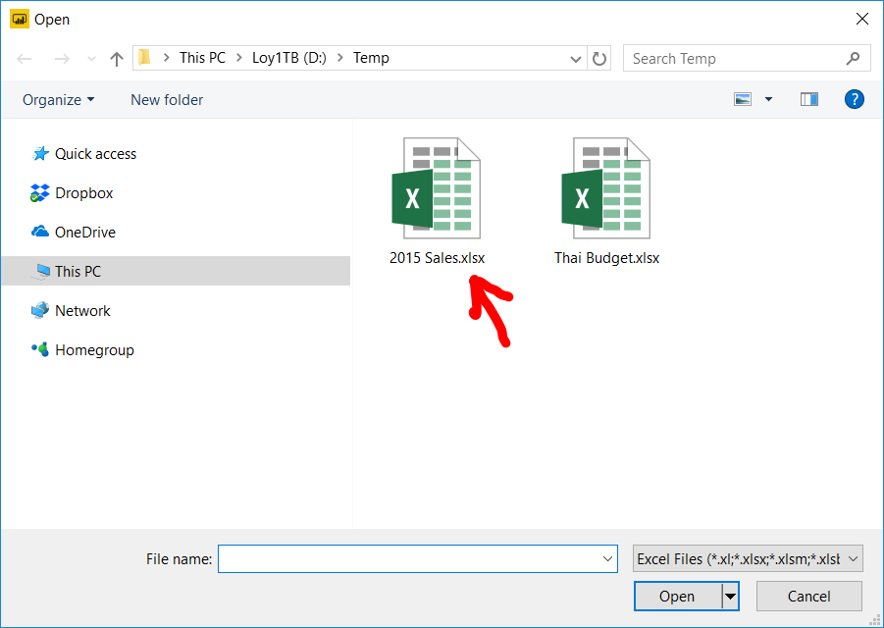

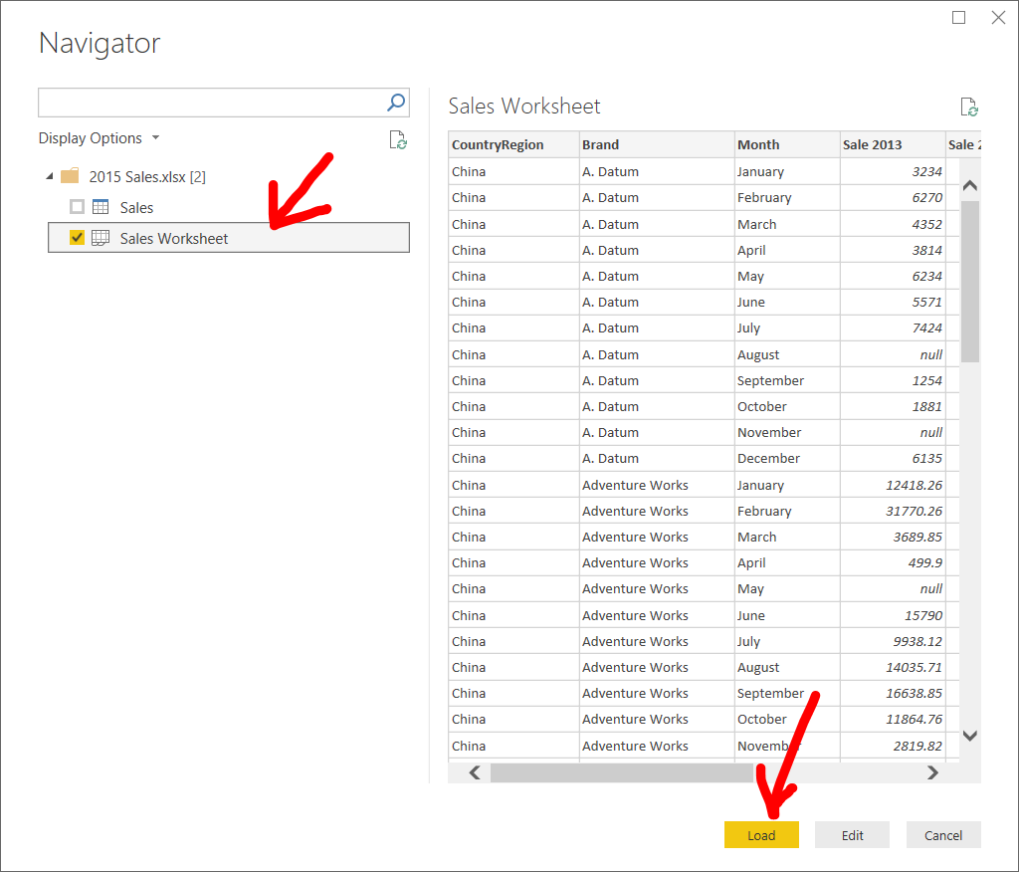

Sale 2015 by Brand

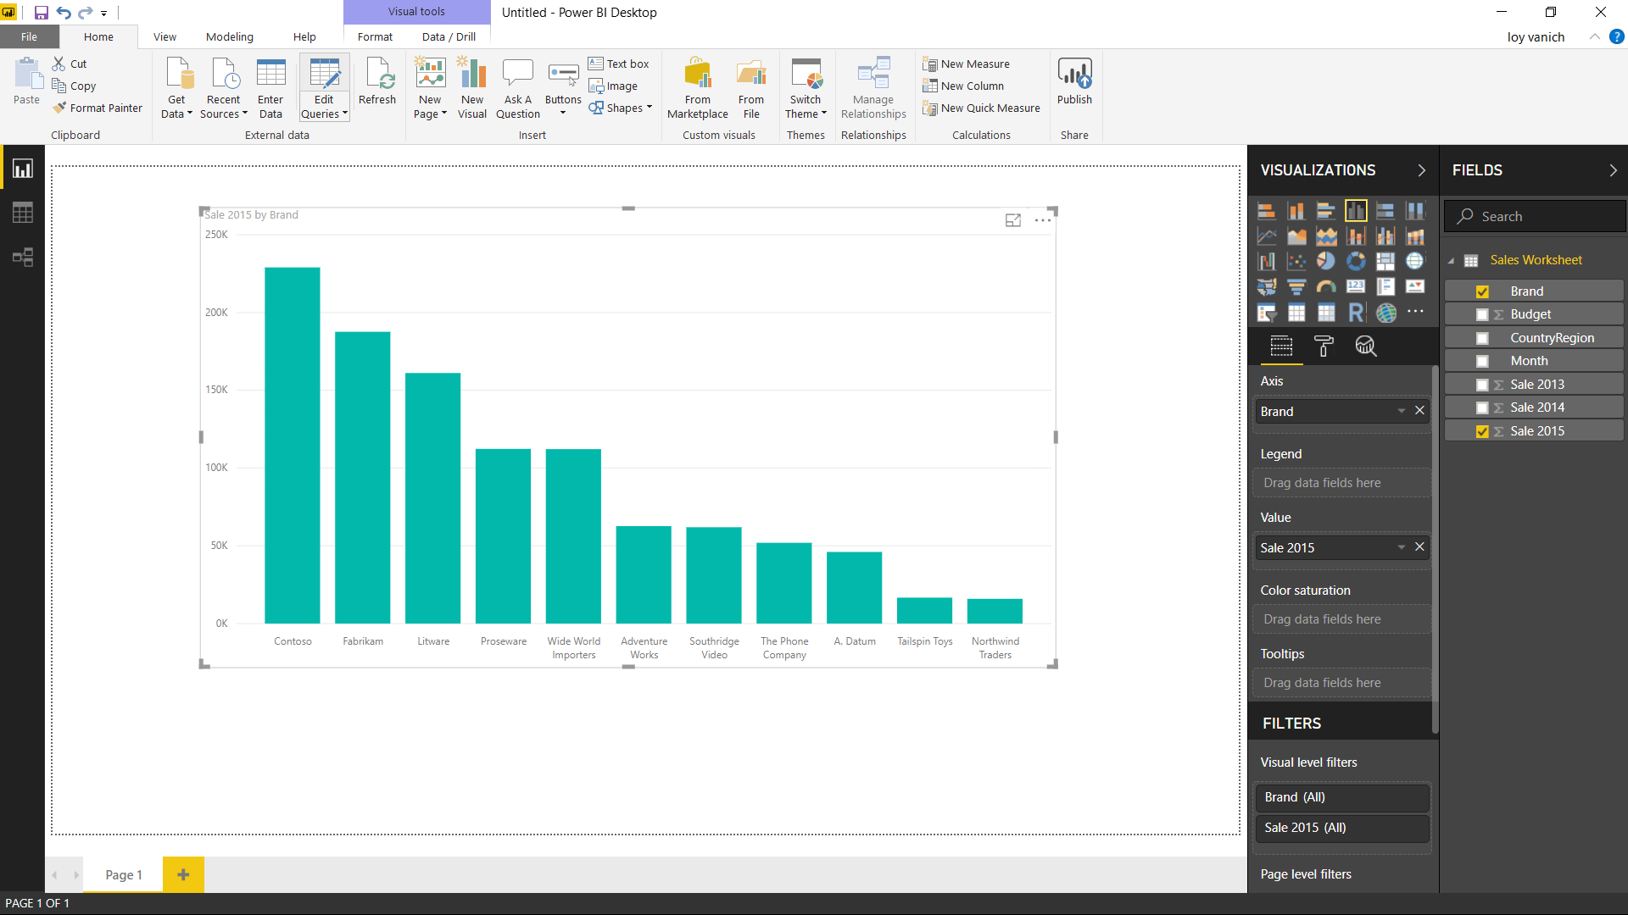

Save Report

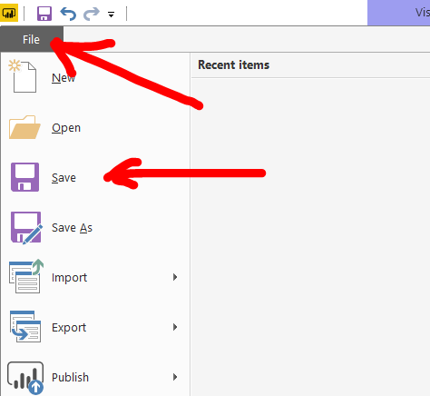

Exercise

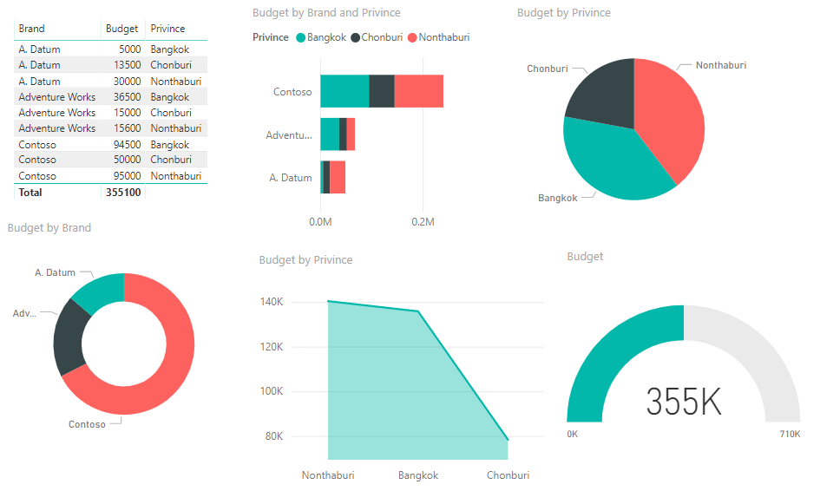Create this report from Thai Budget.xlsx in Desktop Power BI and Save to C:\temp\ThaiReport2.pbix

**Map**

Get Data / Excel

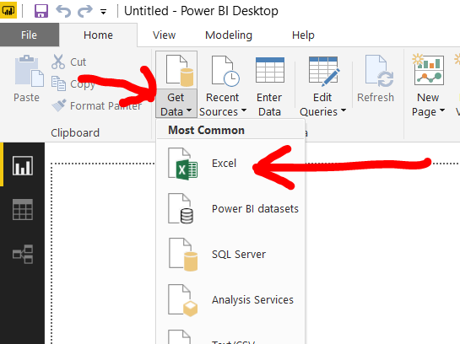

Thai Budget.xlsx

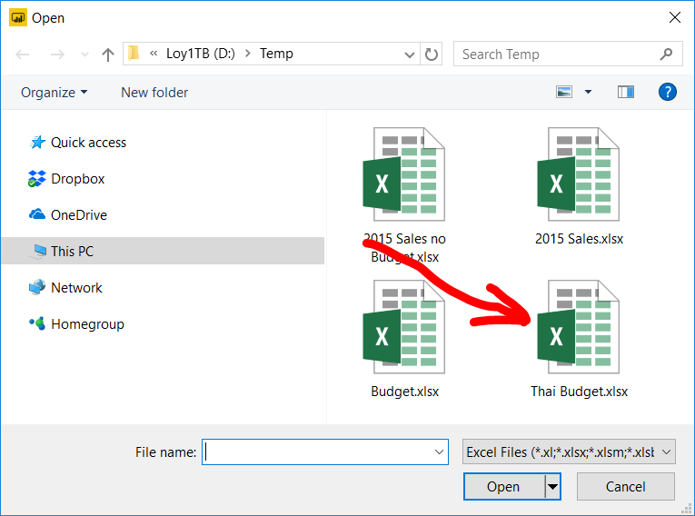

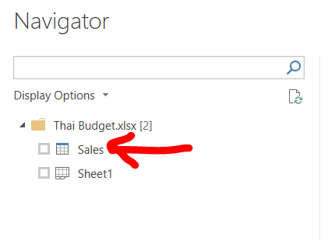Sales / Load

Click tab Modeling

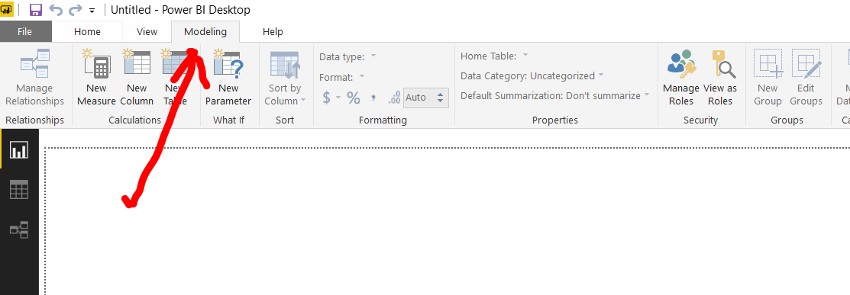

Click Province

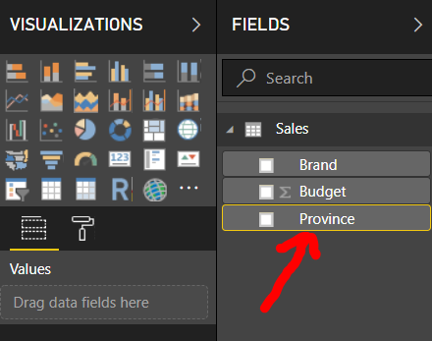

Data Category / City

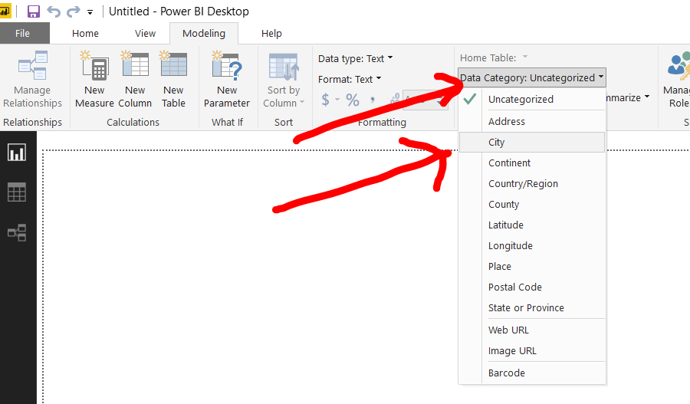

Notice Globe icon

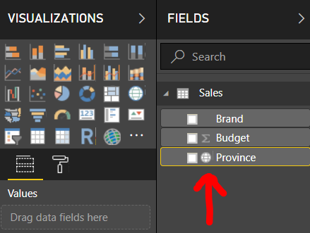

Province / Budget / Map

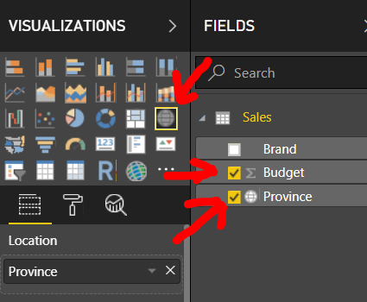

Adjust Map’s size

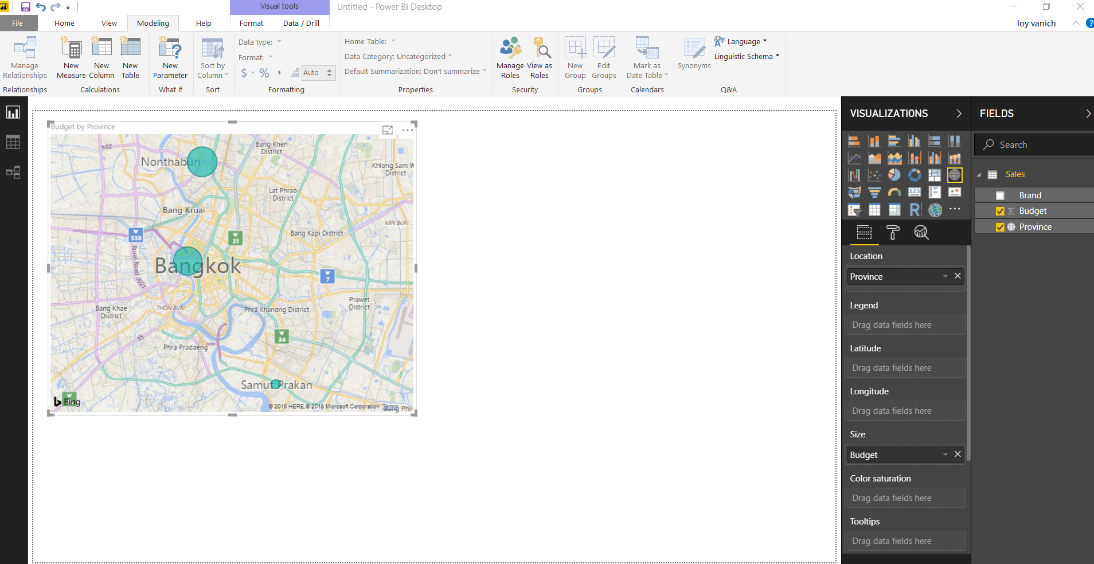

Add Filled Map

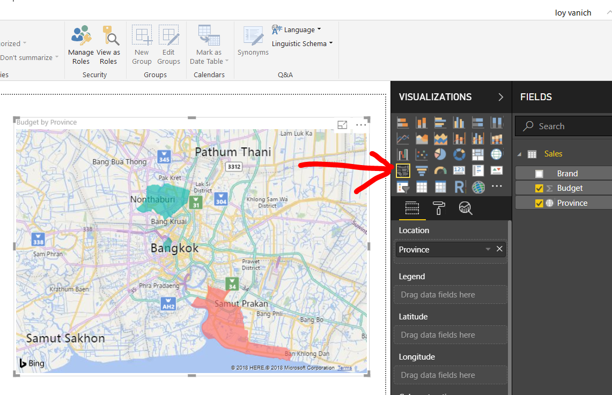

Click each province to see interaction

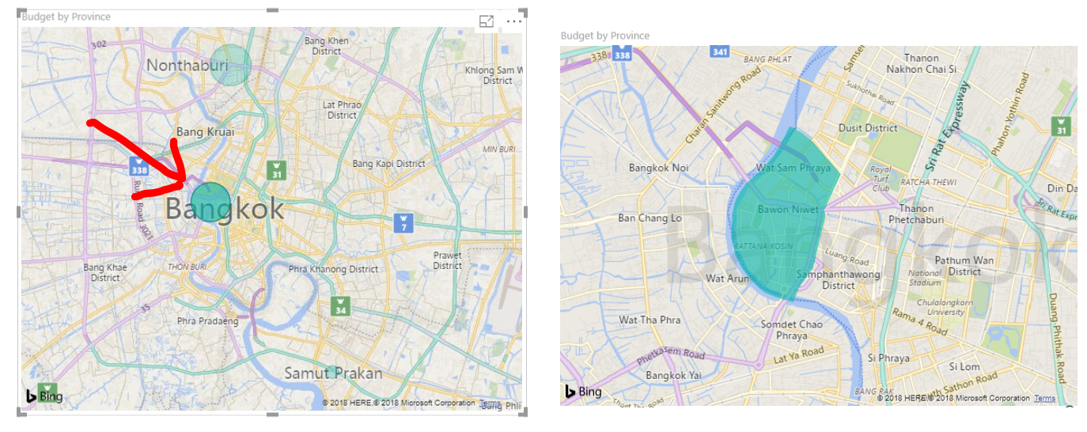

Exercise

Use North Budget.xlsx to create map as shown below

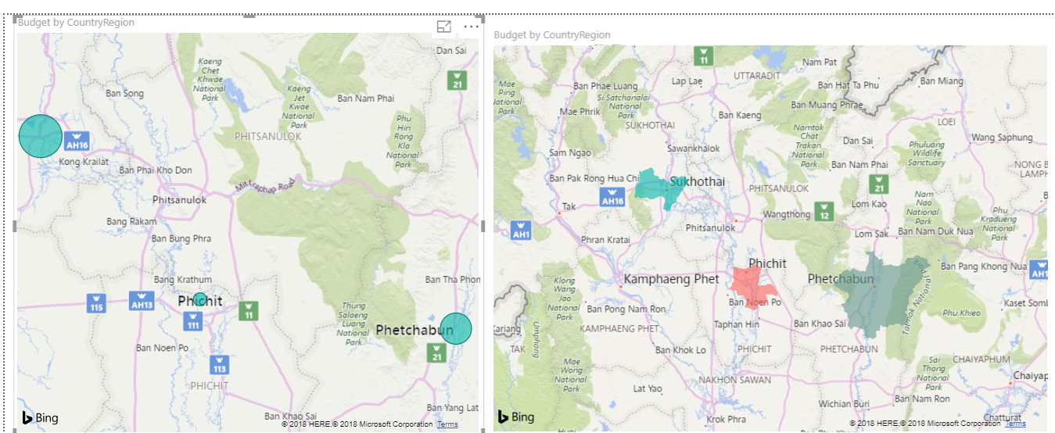

**Query Editor**

**Introduction**

Join two data source

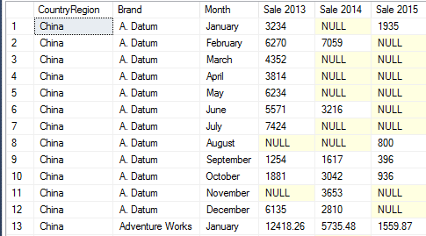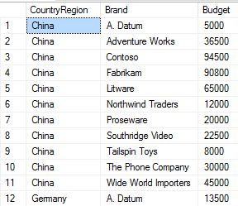Budget Sales 2015

File / New / Edit Queries

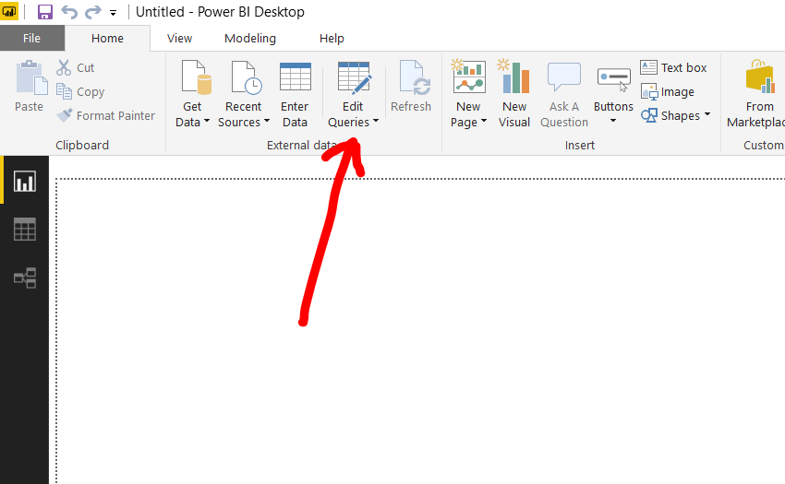

Query Editor / New Source

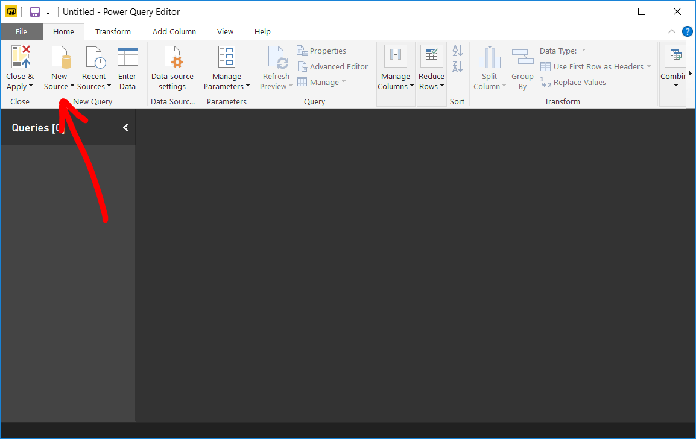

Budget.xlsx

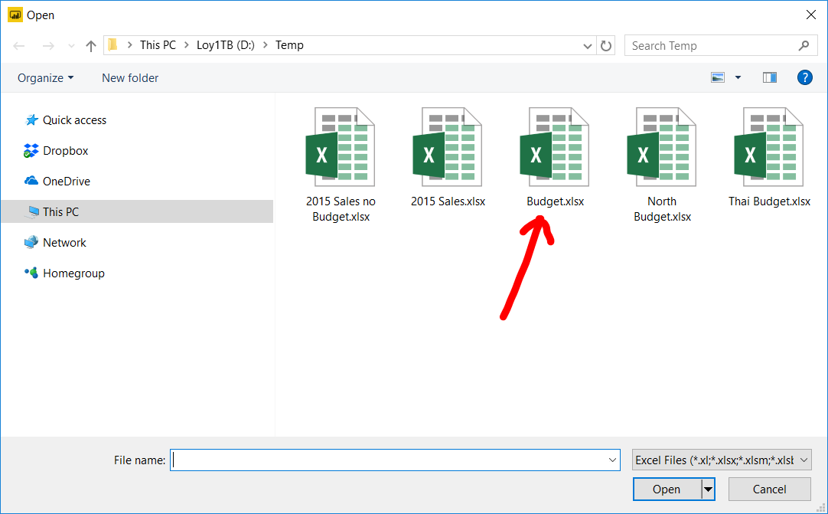

Sales

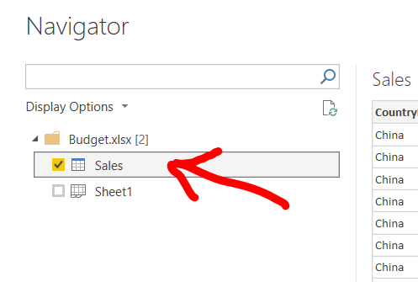

Rename Budget to Budget YTD

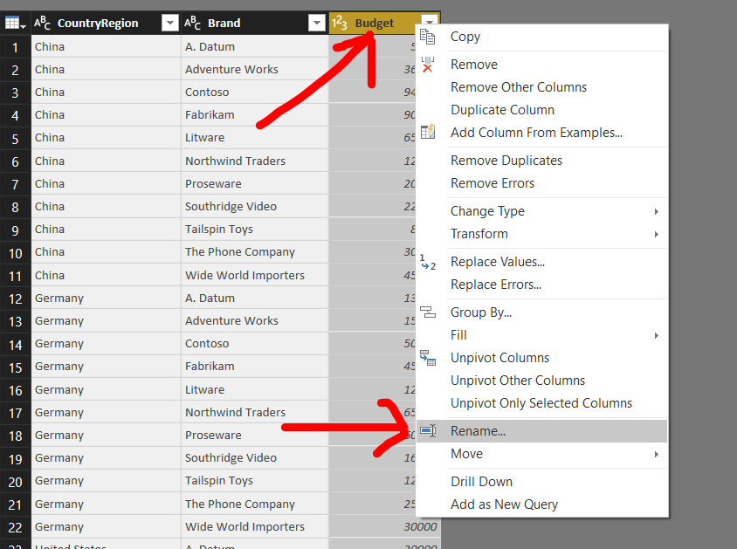

Rename Sales to Budget

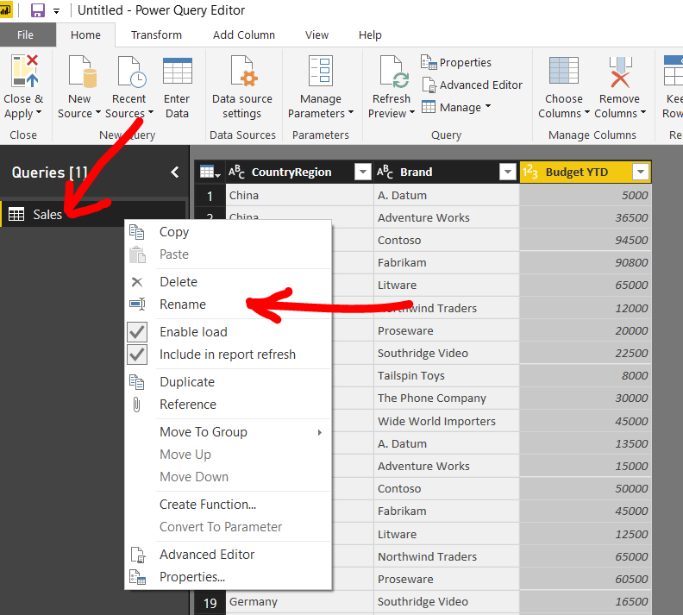

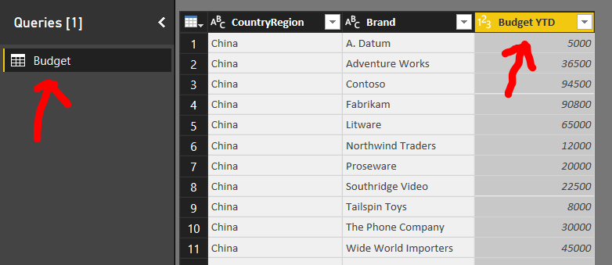Result after renaming

New Source / Excel

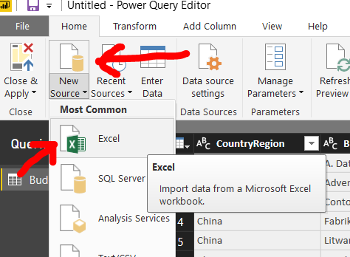

2015 Sales no Budget.xlsx

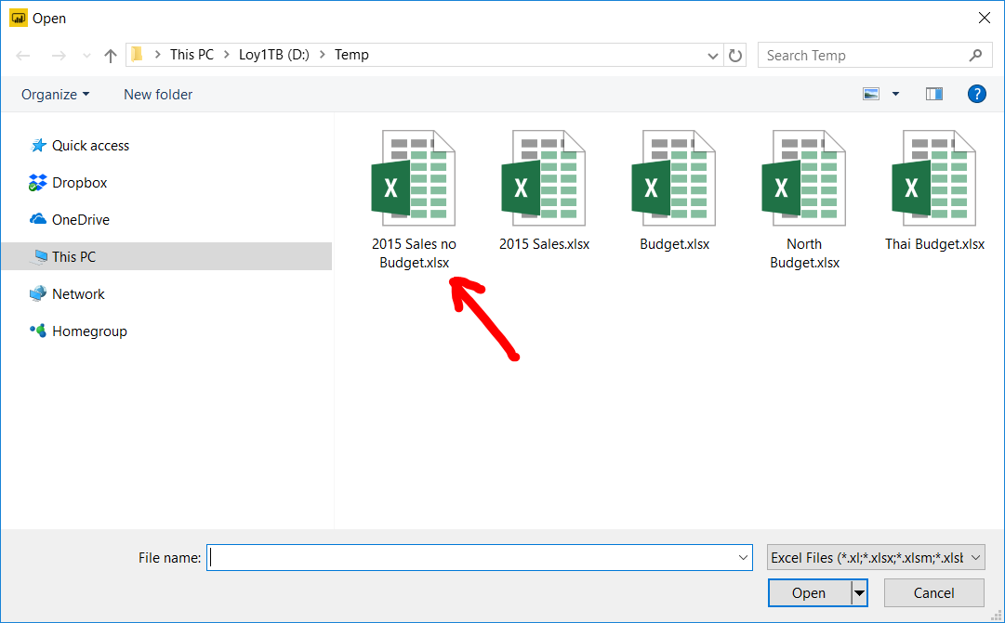

Sales / Load

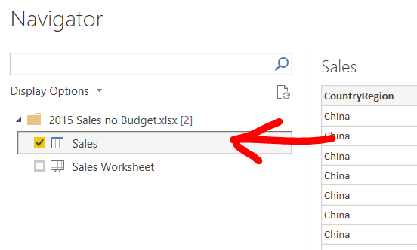

Make sure that you have two data source

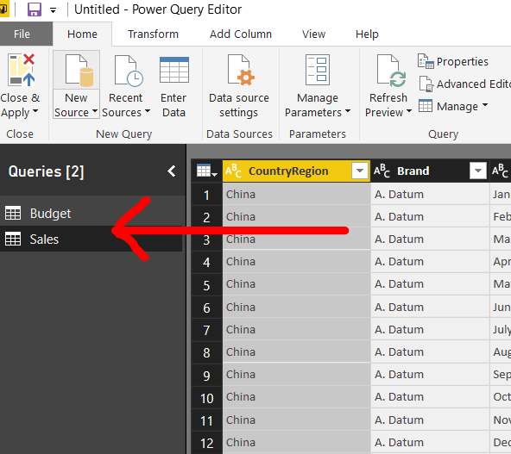

Click Merge Queries

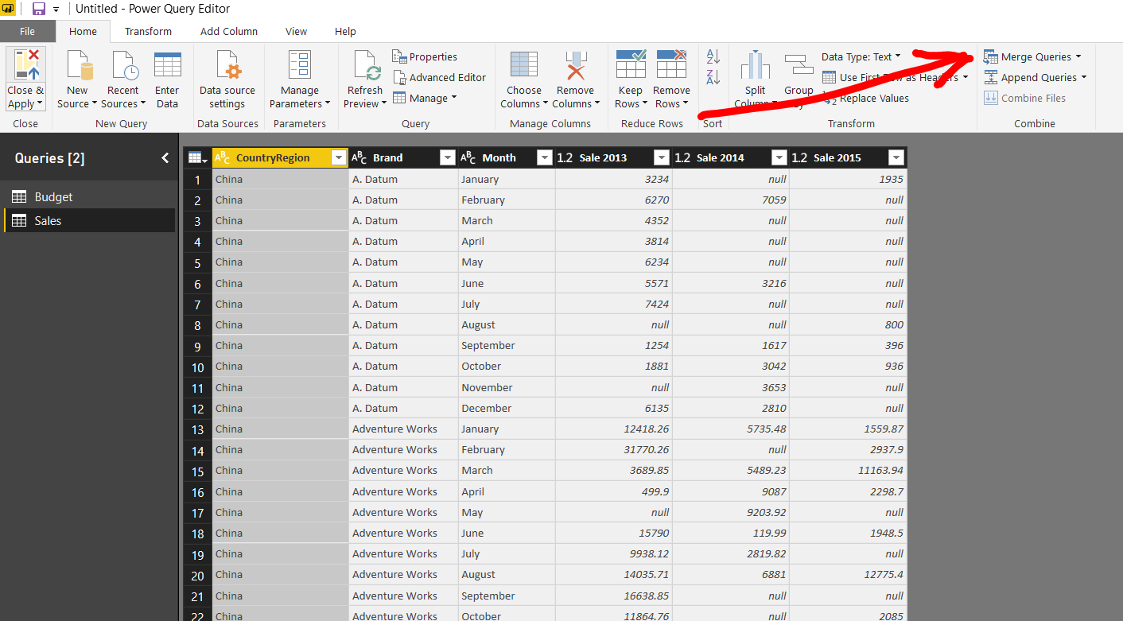

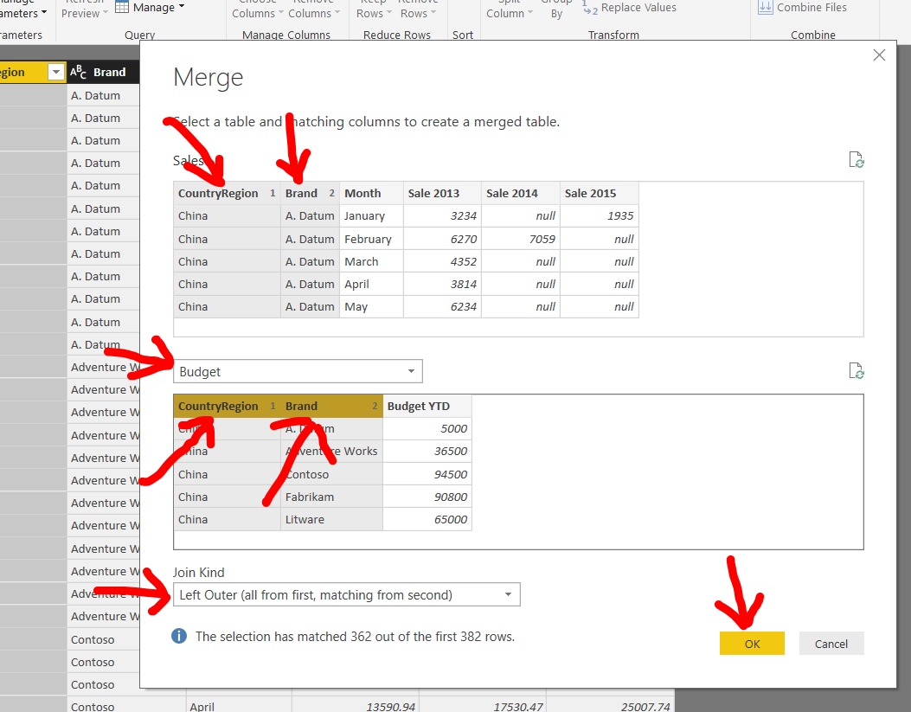Join two data sources

Select Budget YTD

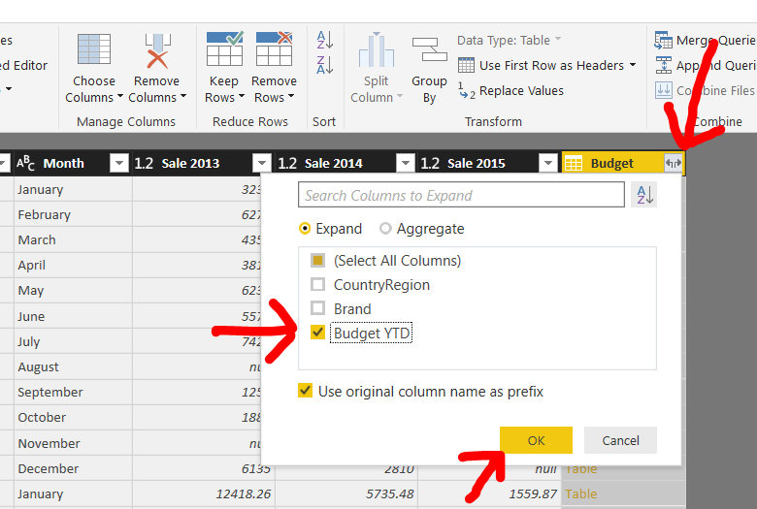

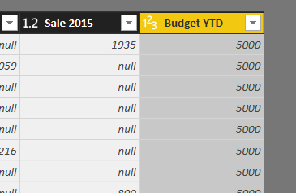Rename Budget.Budget YTD to Budget YTD

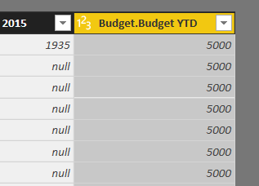

Add Column / Custom Column

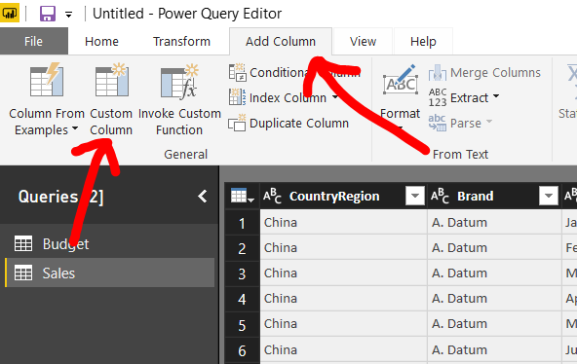

Budget YTD / << Insert

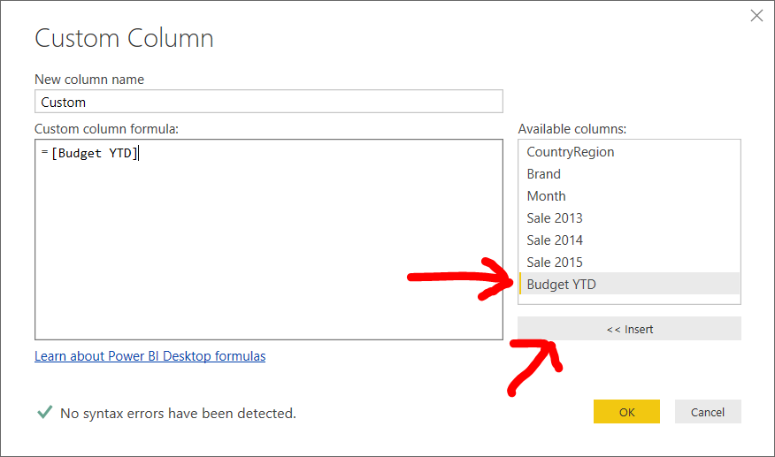

Type / 12 press OK

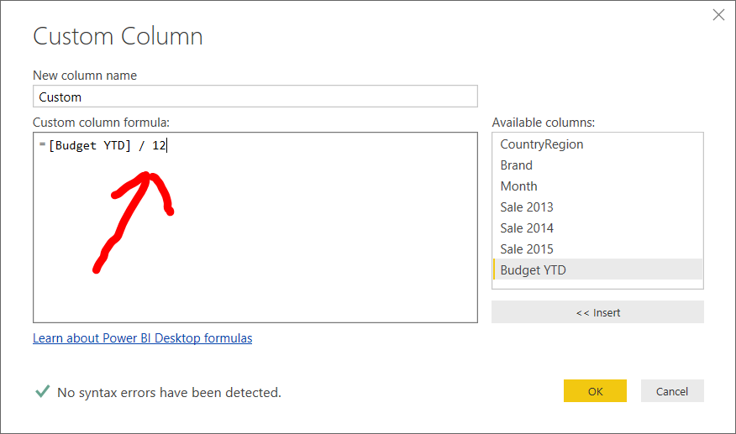

Make sure you have new column name Custom / Rename to Budget

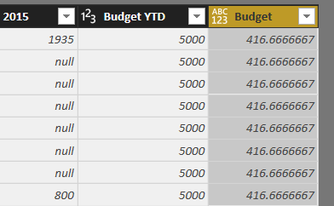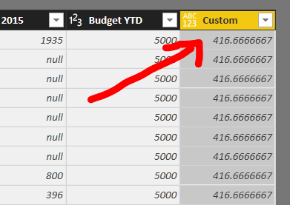

File / Close & Apply

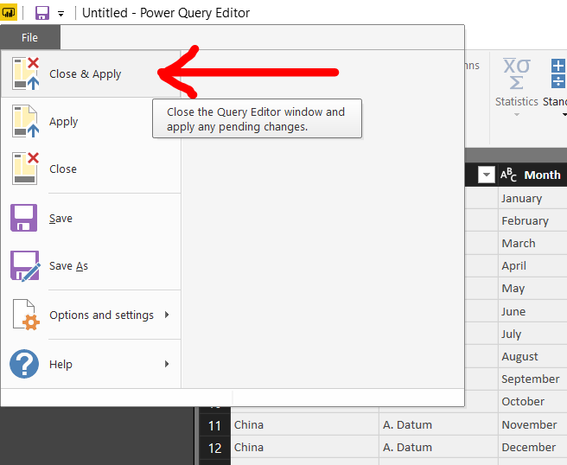

Make sure you have two data source / Sale have column Budget

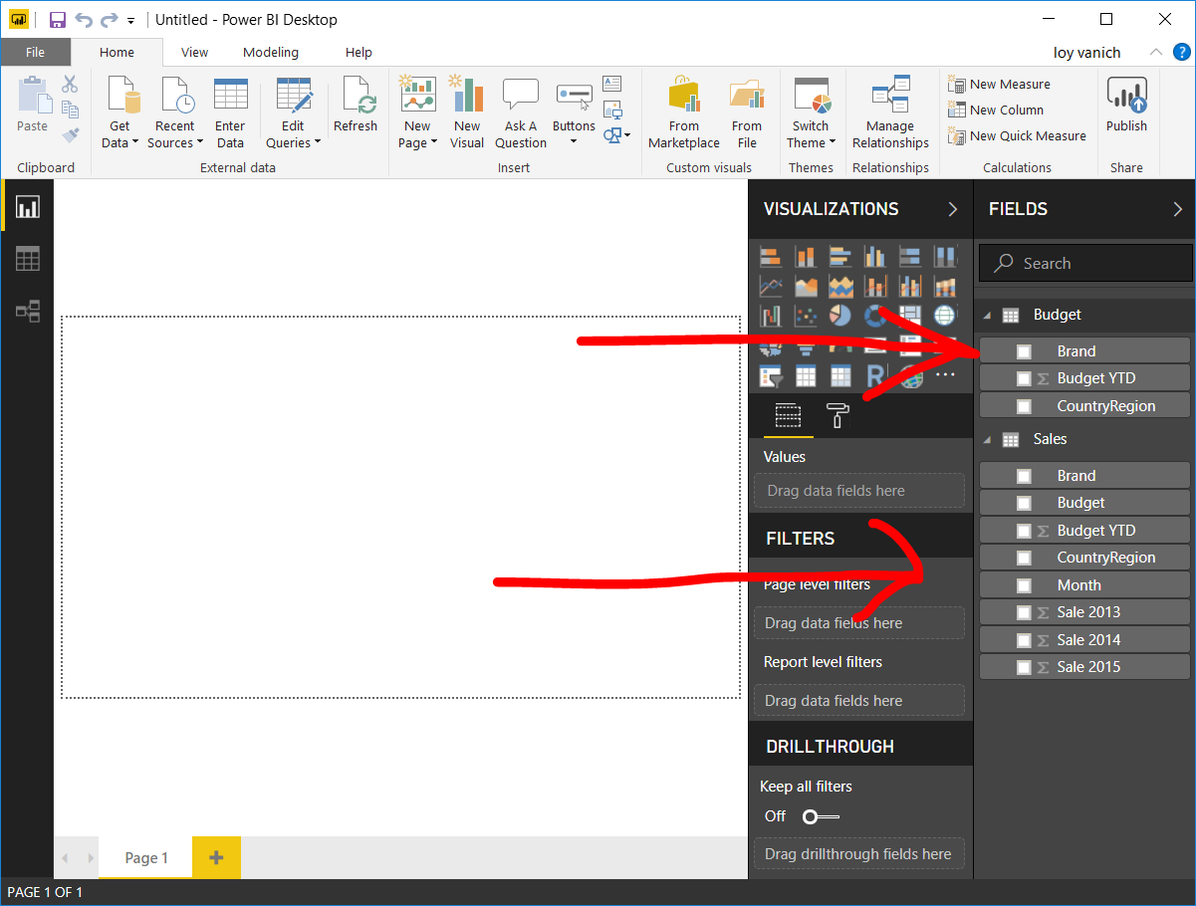

Click Budget / Modeling, Data type, Whole Number

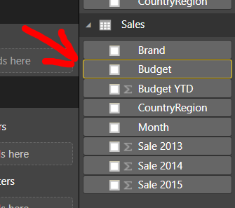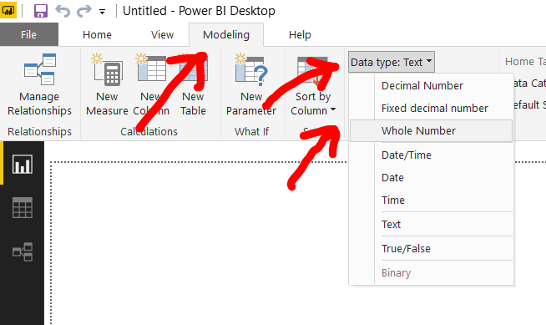

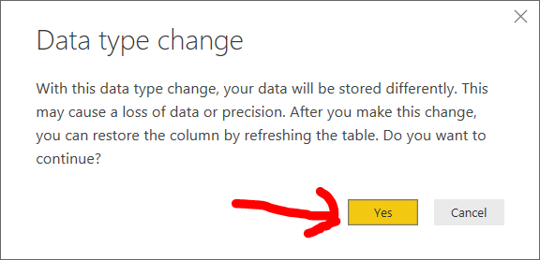Confirm data type chang

Make Clustered column chart Budget and Sale 2015 by Brand

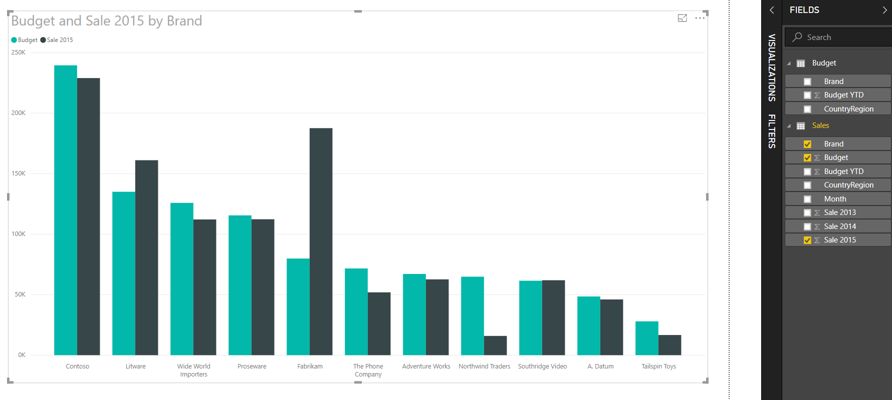

Exercise

New / Create all steps / Make Budget by CountryRegion map

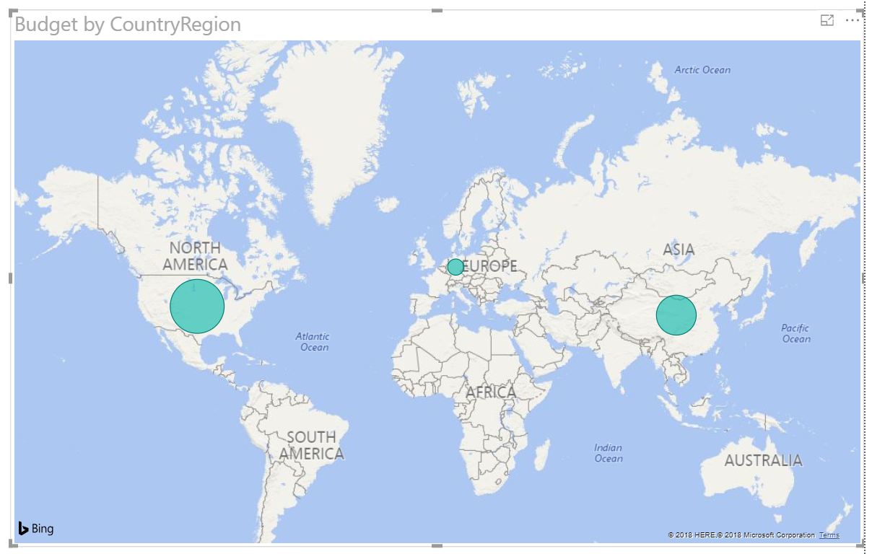

**Sorting**

Create this visual from 2015 Sales for Sort.xlsx

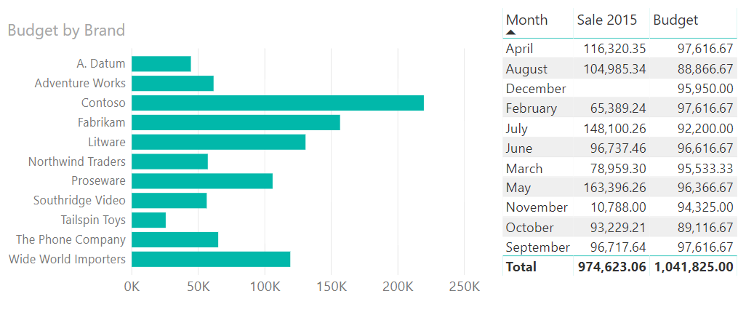

Enter Data / Month Number

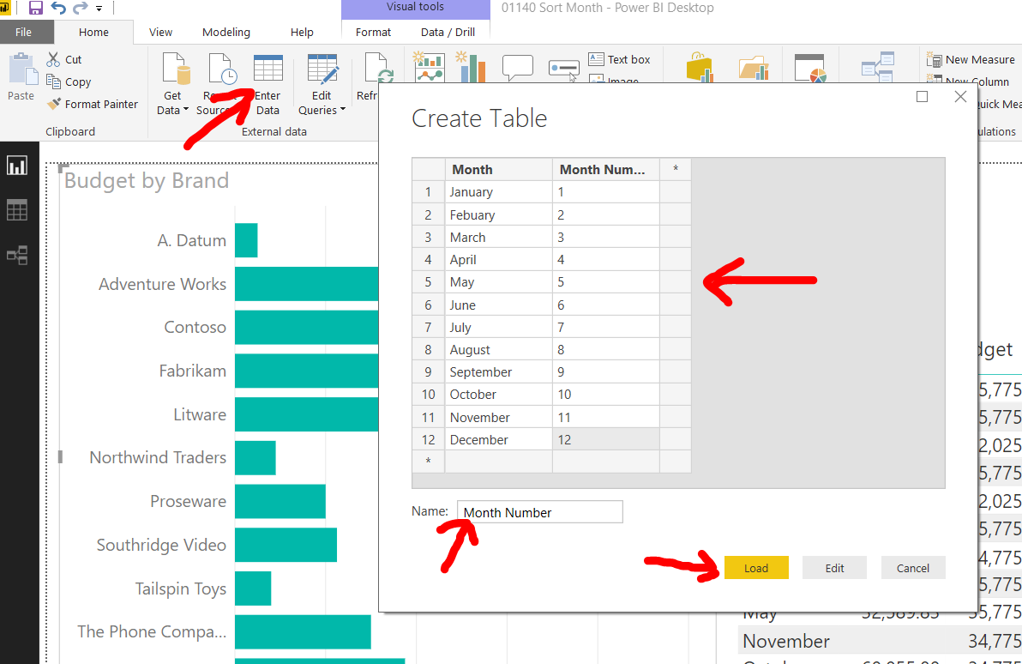

Make sure you have this new Data set

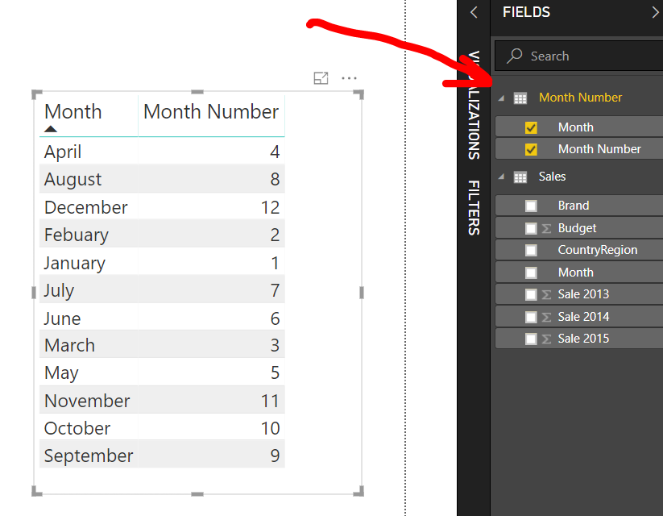

Sort by Month Number

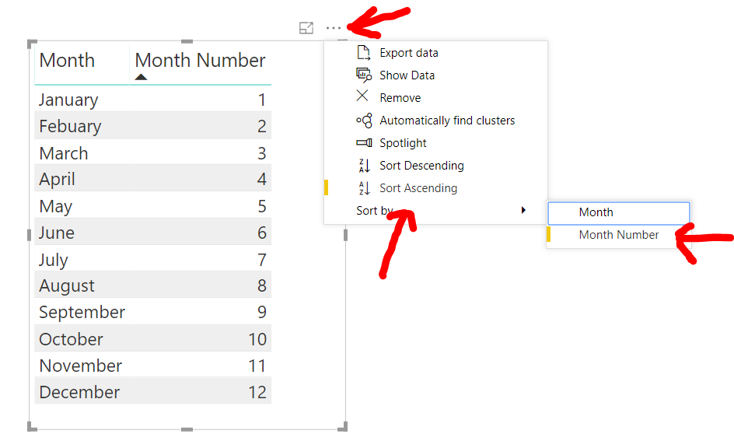

Edit Queries

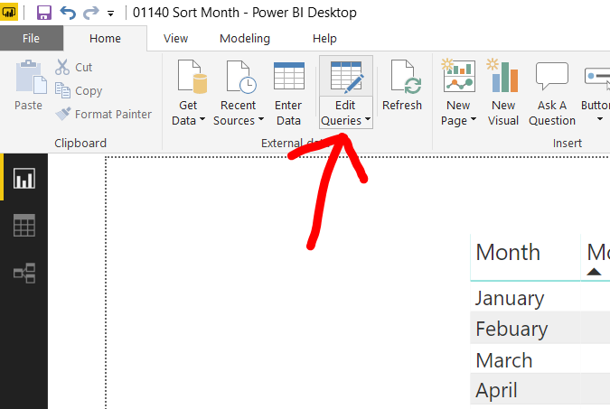

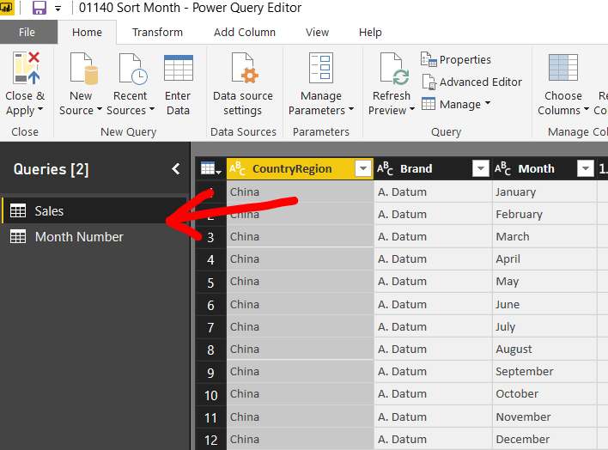Make sure you have both Sales and Month Number in Query Editor

Merge Sale to Month Number on Month

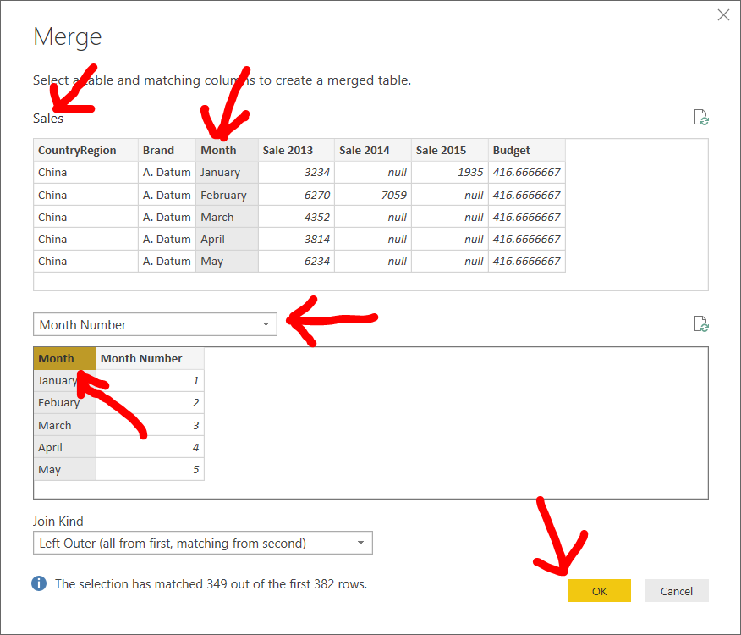

Select Month Number

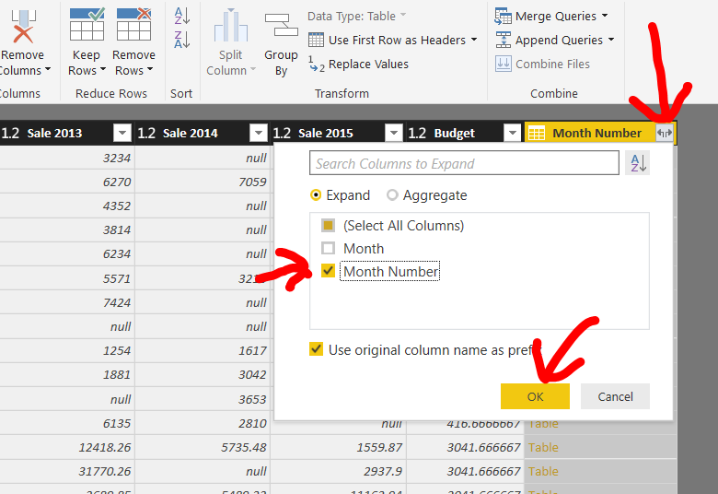

Rename the column

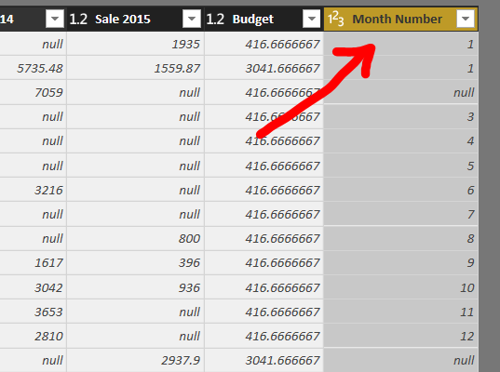

Close & Apply

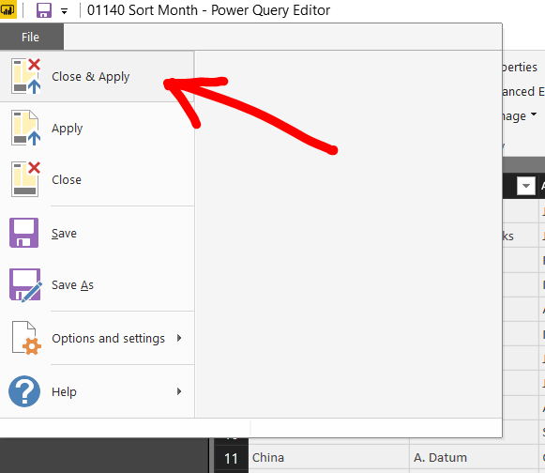

Click Visualize / Click Month

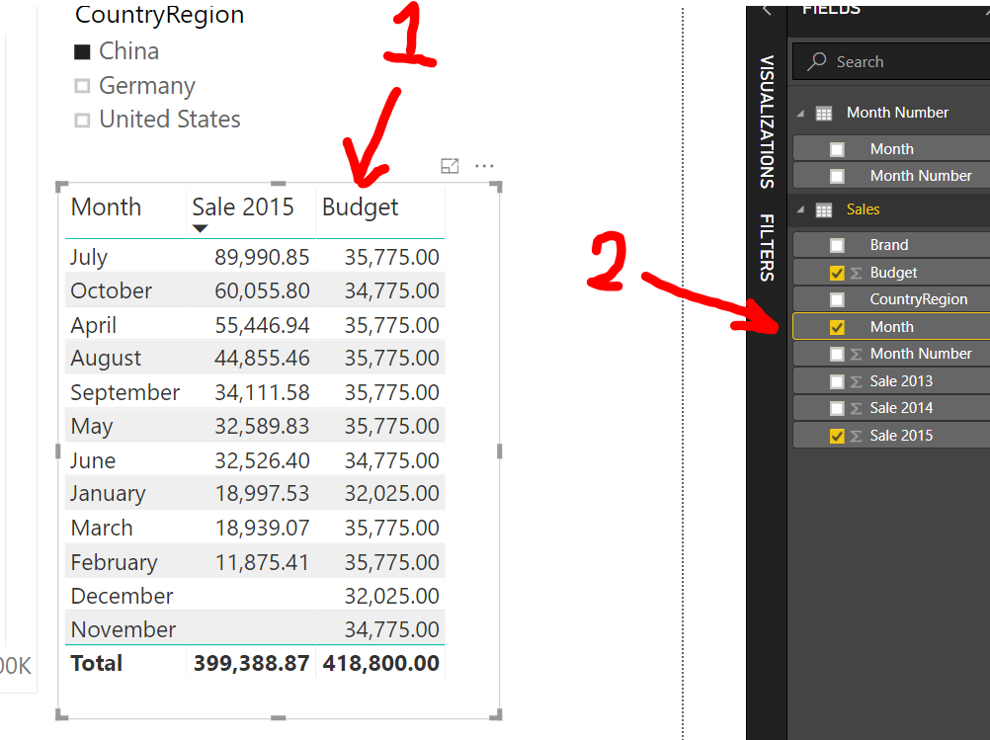

Click Sort by Column / Month Number

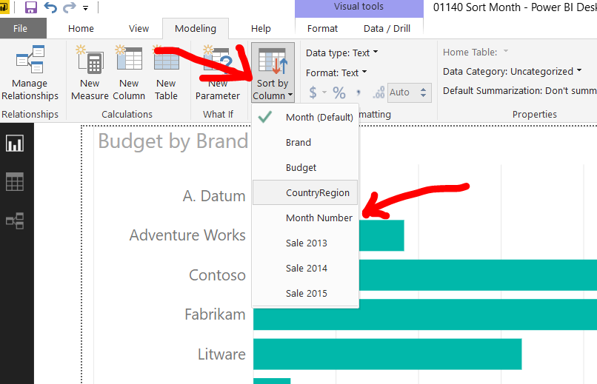

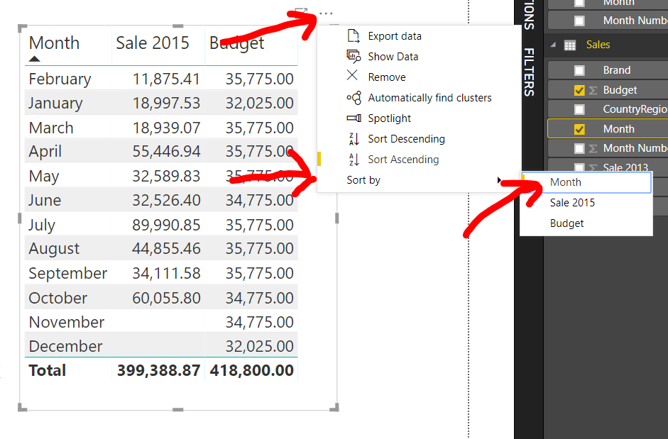Sort by Month

Final Result

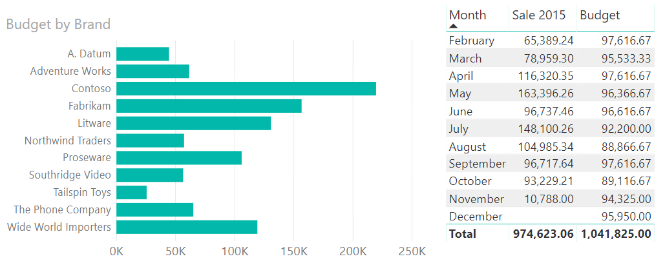

Exercise

New / Repeat all steps / Create below visuals

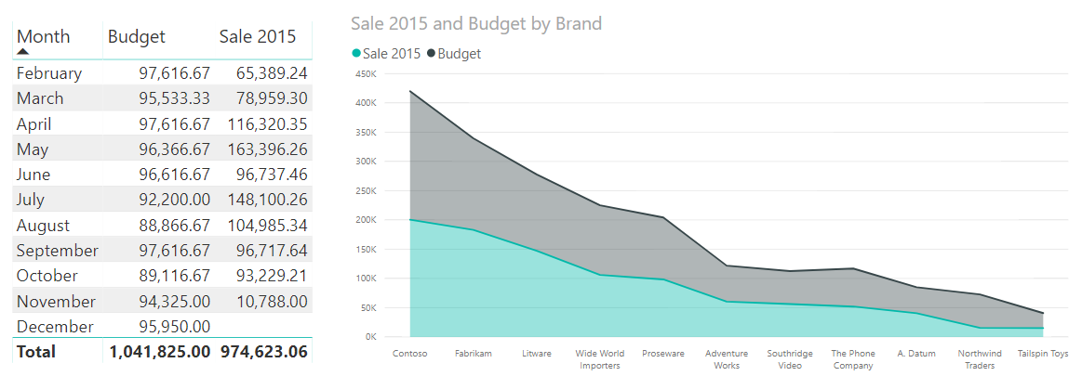

**Custom Column**

Create this visual from 2015 Sales.xlsx

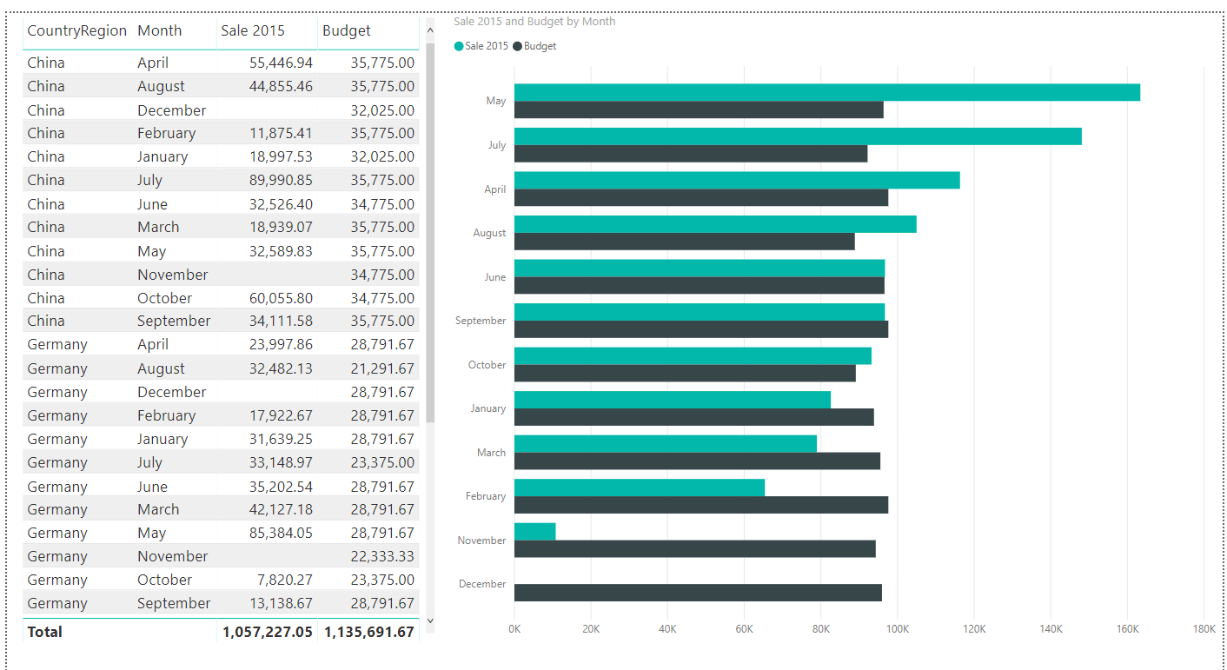

We want to clear Budget if Sale = 0

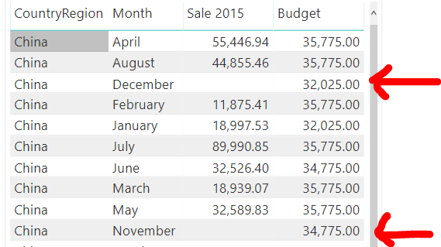

Edit queries

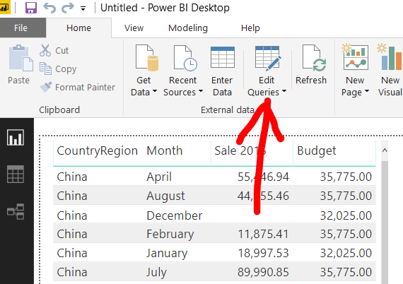

Add Column / Custom Column

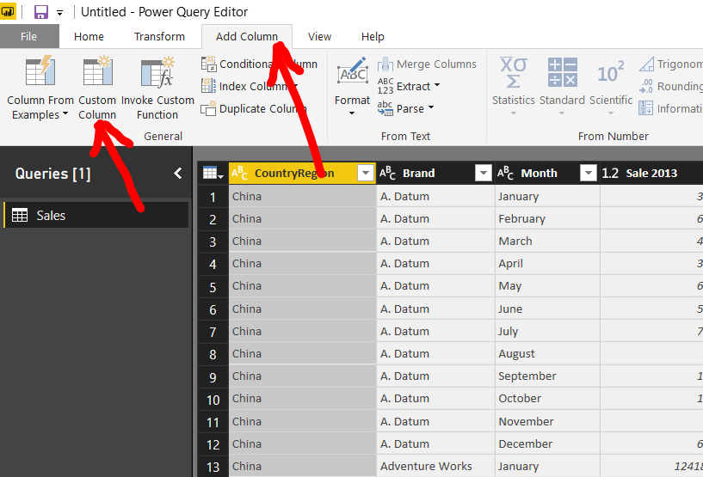

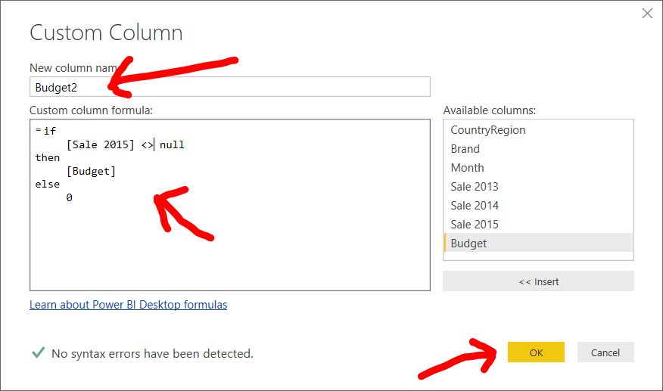Enter name and formula

Close & Apply

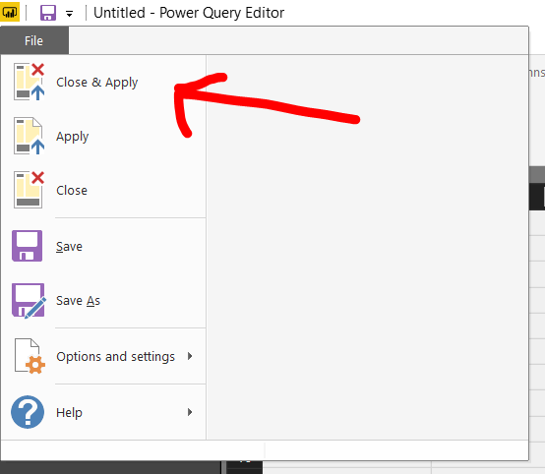

Final result

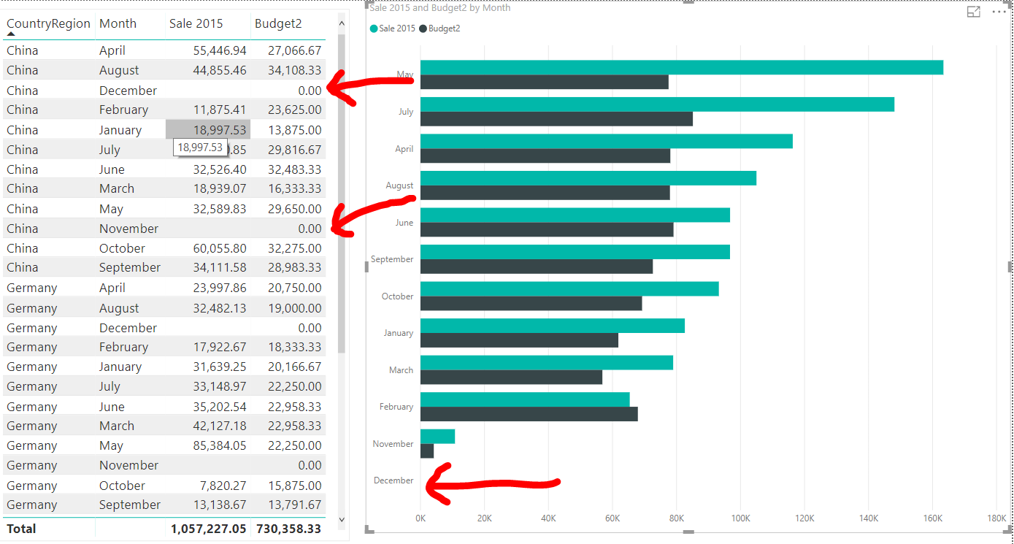

Exercise

Add custom column Total Sale which the value come from 3 years sale of each brand

